CWMA Laws and Regulations (L&R) Committee
2024 Annual Meeting Agenda
Mrs. Sandy Wyss, Committee Chair
Missouri
INTRODUCTION
The L&R Committee (hereinafter referred to as the “Committee”) submits this Committee Interim Report for consideration by the National Conference on Weights and Measures (NCWM). This report contains the items discussed and actions proposed by the Committee during the January Interim Meeting. The report will address the items in Table A during the Interim Meeting. Table A identifies the agenda items by reference key, title of item, page number and the appendices by appendix designations. The acronyms for organizations and technical terms used throughout the agenda are identified in Table B. The headings and subjects apply to NIST Handbook 130, “Uniform Laws and Regulations in the Areas of Legal Metrology an Engine Fuel Quality,” and NIST Handbook 133, “Checking the Net Contents of Packaged Goods.” The first three letters of an item’s reference key are assigned from the Subject Series List. The status of each item contained in the report is designated as one of the following: (D) Developing Item: the Committee determined the item has merit; however, the item was returned to the submitter or other designated party for further development before any action can be taken at the national level; (A) Assigned Item: the committee has assigned development of the item to a recognized subcommittee or task group within NCWM. (I) Informational Item: the item is under consideration by the Committee but not proposed for Voting; (V) Voting Item: the committee is making recommendations requiring a vote by the active members of NCWM; (W) Withdrawn Item: the item has been removed from consideration by the Committee.
Some Voting Items are considered individually; others may be grouped in a consent calendar. Consent calendar items are Voting Items that the Committee has assembled as a single Voting Item during their deliberation after the Open Hearings on the assumption that the items are without opposition and will not require discussion. The Voting Items that have been grouped into consent calendar items will be listed on the addendum sheets. Prior to adoption of the consent calendar, the Committee will remove specific items from the consent calendar upon request to be discussed and voted upon individually.
Committees may change the status designation of agenda items (Developing, Informational, Assigned, Voting and Withdrawn) up until the report is adopted, except those items which are marked Developing, Informational, Assigned or Withdrawn cannot be changed to Voting Status. Any change from the Committee Interim Report (as contained in this publication) or from what appears on the addendum sheets will be explained to the attendees prior to a motion and will be acted upon by the active members of NCWM prior to calling for the vote.
An “Item under Consideration” is a statement of proposal and not necessarily a recommendation of the Committee. Suggested revisions are shown in bold face print by striking out information to be deleted and underlining information to be added. Requirements that are proposed to be nonretroactive are printed in bold faced italics. Additional letters, presentation and data may have been submitted for consideration with this item. Please refer to https://www.ncwm.com/publication-16 to review these documents.
All sessions are open to registered attendees of the conference. If the Committee must discuss any issue that involves proprietary information or other confidential material; that portion of the session dealing with the special issue may be closed if (1) the Chairman or, in his absence, the Chairman-Elect approves; (2) the Executive Director is notified; and (3) an announcement of the closed meeting is posted on or near the door to the meeting session and at the registration desk. If possible, the posting will be done at least a day prior to the planned closed session.
Note: It is policy to use metric units of measurement in publications; however, recommendations received by NCWM technical committees and regional weights and measures associations have been printed in this publication as submitted. Therefore, the report may contain references to inch-pound units.
Subject Series List
Handbook 130 – General GEN Series
Uniform Laws
Uniform Weights and Measures Law WAM Series
Uniform Weighmaster Law WML Series
Uniform Fuels and Automotive Lubricants Inspection Law FLL Series
Uniform Regulations
Uniform Packaging and Labeling Regulation PAL Series
Uniform Regulation for the Method of Sale of Commodities MOS Series
Uniform Unit Pricing Regulation UPR Series
Uniform Regulation for the Voluntary Registration of Servicepersons and Service Agencies
for Commercial Weighing and Measuring Devices RSA Series
Uniform Open Dating Regulation ODR Series
Uniform Regulation for National Type Evaluation NTP Series
Uniform Fuels and Automotive Lubricants Regulation FLR Series
Uniform E-commerce Regulation ECM Series
Examination Procedure for Price Verification PPV Series
NCWM Policy, Interpretations, and Guidelines POL Series
Handbook 133 NET Series
Other Items OTH Series
Table A
Table of Contents
Reference Key | Title of Item | L&R Page
PAL – Uniform Packaging and Labeling Regulation 95

PAL-24.1 W 10.11. Cannabis and Cannabis-Containing Products. 95
MOS – uniform regulation for the Method of Sale of commodities 100

MOS-24.2 I 2.16.3.1. Tare Weights, Part (c) Allowable difference. 100

MOS-24.3 W 2.16.3.1. Tare Weights, Part (d) Average requirement. 104

MOS-24.4 W 2.16.3.1. Tare Weights, Part (e) Tare Determination. 106
RSA – Uniform Regulation for the voluntary Registration of Service Persons and Service Agencies for Commercial Weighing and Measuring Devices 108

RSA-24.1 V Section 4. Voluntary Registration 108
FLR – uniform fuels and automotive lubricants regulation 112

FLR-23.3 W Section 2.20. Hydrogen Fuel. 112
NET – Handbook 133: Checking the Net Content of Packaged Goods 114

NET-22.1 V HB133, Section 1.2.6. Deviations Caused by Moisture Loss or Gain and Section 2.3.8. Table 2-3 Moisture Allowances. 114

NET-24.2 V Section 4.9. Procedure for Checking the Contents of Specific Agriculture Seed Packages Labeled by Count., and Appendix D. AOSA Rules for Testing Seeds. 121
OTH – OTHER ITEMS 129

OTH-24.1 A X. Uniform Shipping Law 129

OTH-07.1 D Fuels and Lubricants Subcommittee 136

OTH-11.1 D Packaging and Labeling Subcommittee 137
item block 1 (b1) V renewable diesel and diesel 138

B1: MOS-23.1 V Sections 2.31. Biodiesel and Biodiesel Blends and 2.40. Diesel Fuel. 139

B1: FLR-23.1 V Sections 1.9. Biodiesel Blend., 1.15. Diesel Fuel., 1.27. Fuel Oil., 2.2. Diesel Fuel., 3.3. Diesel Fuel., and 3.15. Biodiesel and Biodiesel Blends. 141
item block 2 (b2) Reference ASTM Standards D8080 and D8487 148

B2: FLR-24.2 V 2.9. Liquefied Natural Gas (LNG) Vehicle Fuel., 2.10. Compressed Natural Gas (CNG)., and 2.XX. Compressed Natural Gas (CNG) Blended with Hydrogen 148

B2: FLR-24.1 V 3.11.2.1.X. Identification of Grade. and 3.12.2.X. Identification of Grade. 149
item block 3 (b3) Ice cream 152

B3: NET-24.1 V Ice Cream Novelties 152

B3: MOS-24.5 I Section 1.7.1. Factory Packaged Ice Cream and Similar Frozen Products 163

Table B
Glossary of Acronyms and Terms

Acronym | Term | Acronym | Term
ASTM | ASTM International | NEWMA | Northeastern Weights and Measures Association
API | American Petroleum Institute | NIST | National Institute of Standards and Technology
CFR | Code of Federal Regulations | NCWM | National Conference on Weights and Measures
CWMA | Central Weights and Measures Association | OWM | Office of Weights and Measures
FALS | Fuels and Lubricants Subcommittee | PALS | Packaging and Labeling Subcommittee
FDA | Food and Drug Administration | S&T | Specifications and Tolerances
FTC | Federal Trade Commission | SAE | SAE International
HB | Handbook | SWMA | Southern Weights and Measures Association
ILMA | Independent Lubricant Manufacturers Association | UPLR | Uniform Packaging and Labeling Regulation
L&R | Laws and Regulations | USDA – FSIS | U.S. Department of Agriculture – Food Safety and Inspection Service
LPG | Liquefied Petroleum Gas | USNWG | U.S. National Work Group
MAV | Maximum Allowable Variation | WWMA | Western Weights and Measures Association

Details of All Items
(In order by Reference Key)

PAL – Uniform Packaging and Labeling Regulation

PAL-24.1 W 10.11. Cannabis and Cannabis-Containing Products.

Source:
Doctors for Cannabis Regulation
Purpose:
Provide states with a universal symbol to clearly identify products containing intoxicating cannabinoids. At present, there are several symbols being used which is an issue right now with multistate Cannabis license holders who are required to have different packaging in each jurisdiction. NCWM providing a symbol that states can adopt as they see fit can begin to harmonize under one symbol, which will avoid major headaches in the event of federal legalization.
Item under Consideration:
Amend Handbook 130 Uniform Packaging and Labeling Regulation as follows:
  - Cannabis and Cannabis-Containing Products ^{(See} ^{Section} ^{10.11.} ^{NOTE)}

    - Definition. – Cannabis is a genus of flowering plants in the family Cannabaceae, of which Cannabis sativa, indica, ruderalis are species., and any hybridization thereof. This definition includes products that contain 0.3 percent or less of Total Delta-9 Tetrahydrocannabinol (THC) (also known as Hemp) and products that contain more than 0.3 percent of Total Delta-9 THC (also known as cannabis, marijuana, or marihuana).

    - Labeling. – Any Cannabis or Cannabis-containing products intended for human or animal consumption or application, shall bear on the outside of the package the following:

      - On the principal display panel

1. The statement “Contains Cannabis.” The word “Cannabis” shall be capitalized and italicized;
2. The statement “Contains 0.3 % or less Total Delta-9 THC” or “Contains more than 0.3 % Total Delta-9 THC”; and
3. Shall display a Cannabis Leaf symbol in accordance with the latest version of ASTM D8441/D8441M Standard Specification for an International Symbol for Identifying Consumer Products Containing Intoxicating Cannabinoids.
Previous Status:
2024: New Proposal
Original Justification:
Uniform product identity is crucial to continue establishing consumer trust and equity in each transaction. We believe it’s important that consumers understand whether a product they are buying contains intoxicating cannabinoids.
There are currently 14 different symbols being used in the US, none of which comply with ISO/ANSI standards for warning symbols (table below). The US needs a pathway to uniform intoxicating product identification to solve multistate operator cost of compliance and provide a pathway for a future of interstate commerce.

ASTM International Technical Committee D37 on Cannabis has developed D8441/D8441M Standard Specification for an International Symbol for Identifying Consumer Products Containing Intoxicating Cannabinoids (IICPS), which defines specifications for a harmonized graphical symbol that can be used as a means of identifying consumer products containing intoxicating cannabinoids. The symbol is available without having to pay for the ASTM standard by visiting https://www.dfcr.org/universal-cannabis-symbol or the websites of state agencies who have already adopted it, which are Montana, Vermont, South Dakota, and New Jersey.

Multi-state operators currently have different symbol requirements, with compliance cost and hassle involved in having to use different symbols in different states. Providing the industry with the option of adopting a symbol based on a consensus standard positions NCWM to become the natural answer to a future of interstate commerce, likely after future federal legalization, making the NIST Handbook 130 the ideal home for reference to a universal symbol that provides states the option to adopt at their own discretion at any pace they like, before or after any federal legalization.
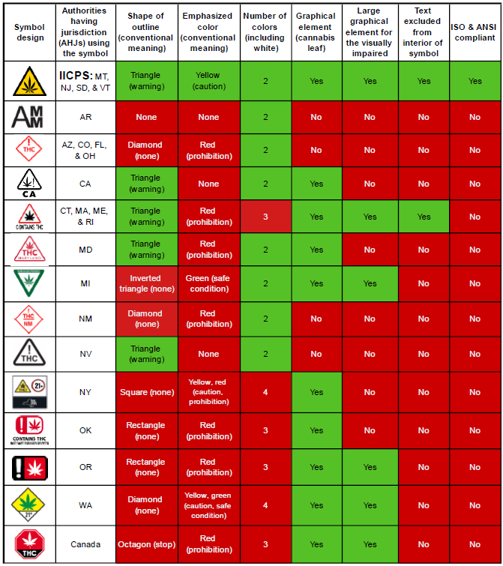
The submitter pointed out the following possible arguments and responses.
NCWM doesn’t measure intoxicating cannabinoids, so we shouldn’t have to label it. We think this is not unlike the recently passed regulations requiring “Cannabis” to appear on the PDP. Here, we’re going further with product identification.

The CTG just passed product identification standards. Why this now? The Cannabis industry is dynamic and travels faster than the recently approved standards that were originally submitted years ago

This will conflict with the symbol selected by my state. States have discretion on adoption. Passing this standard allows for maximum flexibility for states to adopt it when they are ready.
The submitter requested Voting status in 2024.
Comments in Favor:
Regulatory:
- None
Industry:
- None
Advisory:
- None
Comments Against:
Regulatory:
- 2024 Interim: Mr. Kurt Floren, County of Los Angeles, opposed this item stating that this item may be perceived as a warning label and is not appropriate for weights and measures as we are not health experts. Mr. Floren suggested we should stay in our lane.
- 2024 Interim: Mr. Matt Douglas, California concurred with Mr. Minnich’s Mr. Floren’s comments.
- 2024 Interim: Mr. Jim Willis, New York concurred and echoed Mr. Floren’s comments.
Industry:
- None
Advisory:
- 2024 Interim: Mr. Loren Minnich, NIST OWM – Informed the Committee that comments were submitted in writing to the committee. He summarized by stating that marijuana as a federally recognized Schedule 1 substance vs. hemp.
- 2024 Interim: Mr. Charlie Rutherford, Co-Chair, Cannabis Task Group – The Cannabis Task Group recommends this item be withdrawn.
Neutral Comments:
Regulatory:
- None
Industry:
- None
Advisory:
- None
Item Development:
NCWM 2024 Interim: The Committee hearing no support for the item withdrew it.
Regional Associations’ Comments:
New Proposal
CWMA 2023 Interim: Mike Harrington, Iowa commented that this item does not pertain specifically to his state, but he believes it will be federally legalized so supports the standards moving forward. He further commented that states who do not have legal use of cannabis should still be involved in helping develop the standard once it is legalized federally. Chris Guay, CGGT, concurs. He believes having consistency across states is important to establish a benchmark developed by NCWM. Steve Peter, representing himself, concurs and supports the item moving forward. The committee agrees this item is developed and ready for voting status.
WWMA 2023 Annual: Vince Wolpert, Cannabis Task Group stated there will be changes to the last portion of the statement for products containing intoxicating cannabinoids. Recommends item remains assigned to the Cannabis Task Group. Steven Harrington, Oregon, recommended Withdrawal after testimony was heard from several other regulators.
Matt Douglas, California Department of Agriculture, Division of Measurement Standards, had a general inquiry as to whether this is an identity symbol or a warning symbol. Matt encouraged the submitter to work with the Cannabis Task Group to determine if this is the appropriate place for this item, and recommended this item be assigned to the Cannabis Task Group.
Kurt Floren, County of Los Angeles, California stated he was opposed to this item. Kurt stated he supports Cannabis quantity statements, however, does not feel we should be providing warning, as once we step in to regulate warnings, it becomes regular for us to have to do so. Kurt stated that the health issues are better left to health agencies, and that when the federal government moves toward legalization, the FDA and FTC can get involved.
Jose Arriaga, County of Orange, California stated he is in favor of having a harmonizing symbol to identify Cannabis, however, does not support cautionary statements, including the word intoxicating.
Joe Moreo, County of Trinity, California stated this should include an identification, a warning, and a potency, since the federal government defines hemp, THC, and Cannabis by potency. Recommended the item be assigned to the Cannabis Task Group.
The WWMA Laws and Regulations Committee recommends this item be Assigned to the Cannabis Task Group.
SWMA 2023 Annual: The current item under consideration could be interpreted to apply to all Cannabis-containing products and the SWMA recommends the following change to clarify that this requirement does not apply to hemp. SWMA recommends the following language for 10.11.2.(a)3. to move forward as Informational to allow for further vetting of the item.

3. If the product contains more than 0.3% Total Delta-9 THC it shall display a Cannabis Leaf symbol in accordance with the latest version of ASTM D8441/D8441M Standard Specification for an International Symbol for Identifying Consumer Products Containing Intoxicating Cannabinoids.
NEWMA 2023 Interim: Lou Sakin, Holliston, MA, representing the Cannabis Task Group - This is an attempt to standardize (nationwide) a warning symbol on product containing cannabis. Believes the items are ready for voting. He related that the Western Weights and Measures Association recommended it remain as ‘Assigned’ and that some members feel this is not a weights and measures issue. Many states have different symbols.

Jason Flint, NJ – New Jersey already adopts the symbols and wording. ASTM already uses this labeling, and he is in favor of ‘Assigned’ but would vote yes for it.

Jim Willis, NY - Is not in favor of this item as a ‘Voting’ item and should stay ’Assigned”.

Jim Cassidy, MA - Feels it should stay ‘Assigned’.

Marc Parquette, VA - Vermont agrees it should stay ‘Assigned’.

Walter Remmert, PA - Not in favor of this proposal, and in favor of it being ‘Assigned’.
The committee recommends this item to be assigned.

Additional letters, presentation and data may have been submitted for consideration with this item. Please refer to https://www.ncwm.com/publication-15 to review these documents.

MOS – uniform regulation for the Method of Sale of commodities

MOS-24.2 I 2.16.3.1. Tare Weights, Part (c) Allowable difference.
Source:
National Propane Gas Association
Purpose:
Resolve the discrepancy that exists between Handbook 130 and Title 49 of the Code of Federal Regulations with respect to the allowable differences between the stamped tare weight and the actual tare weight of cylinders used for compressed or liquefied gases in refillable cylinders.
Item under Consideration:
Amend the Uniform Regulation for the Method of Sale of Commodities as follows:
2.16.3.1. Tare weights.
…
    - Allowable difference. – If the stamped or stenciled tare is used to determine the net contents of the cylinder, the allowable difference between the actual tare weight and the stamped (or stenciled) tare weight, or the tare weight on a tag attached to the cylinder for a new or used cylinder, shall be within the following limits prescribed by 49 CFR § 178.35:
(1) ¹/₂ % for tare weights of 9 kg (20 lb) or less For a cylinder of 25 pounds or less at the time of manufacture, a lower tolerance of 3 percent and an upper tolerance of 1 percent; or
(2) ¹/₄ % for tare weights of more than 9 kg (20 lb) For a cylinder exceeding 25 pounds at the time of manufacture, a lower tolerance of 2 percent and an upper tolerance of 1 percent.
NOTE: Failure of a cylinder tare weight to be within the required allowable difference is considered a Method of Sale violation. The cylinder shall be removed from use until the tare weight is corrected.
Previous Status:
2024: New Proposal
Original Justification:
The data presented in NIST Special Publication, “NIST SP 2200-01, 2022 NCWM-NIST National Survey on 20 lb LPG (Propane) Cylinders,” is sufficient evidence that the tolerances imposed in Handbook 130 on the marking of tare weights for propane cylinders are not in sync with the real world. For example, the report states that “nearly half (44.3%) of new cylinders and significantly less (32.0% of used cylinders were in compliance with existing tare weight requirements,” (in reference to the current Handbook 130 requirements). Which means, of course, that the great majority of cylinders, even new cylinders, were not in compliance. The reasons for that include the following:
- As quoted from the report, “Initial assessments suggest that cylinder manufactures use a tolerance of 1%, which is primarily based on Measurement Canada’s requirement of 1%.” If a cylinder’s tare weight can vary +/- 1% from stamped value as manufactured, a cylinder’s actual tare weight cannot be expected to be within +/- 0.5% of the marked value after the cylinder at any point in time thereafter.
- For practical reasons, some manufacturers may use a statistical method to arrive at an average tare weight based on previous measurements of a sufficiently large sample pool. Whatever variance there may be in the actual weight of the cylinder versus the marked tare weight, the fact is that over 98% of the new cylinders weighed were in compliance with the DOT tolerances.
- The following statement from the report is very telling: “It is highly unusual and irregular to see a tolerance where a very significant majority of the packages are in compliance (in this case, 98.4%).” The report goes on to state that 34.3% of “used” cylinders would not be in compliance with the DOT tolerances. These two statements call attention to the fact that these grill cylinders are in constant circulation, subject to a wide variety of conditions, treatment and possible abuse by potentially many different customers, thereby underlining the need to steer clear of overburdensome and unwarranted regulation.
- Scales utilized in most retail locations where cylinders are filled are beam scales which do not have the capability of weighing cylinders to the sensitivity or number of decimal places necessary to verify the initial tare weight while a cylinder is under vacuum using Handbook 130 requirements. Additionally, there is no requirement in any national code or standard to fill cylinders by weight at the point of sale when the cylinder is transported for non-commercial use. These cylinders are not considered to be transported “in commerce” and are therefore not required to be filled by weight, thereby allowing for the determination of maximum fill level using the fixed maximum liquid level gauge. Scales are not required to be installed at these facilities.
- Even when the product is released to the atmosphere to “empty” the cylinder, there will always be some amount of liquid and vapor remaining in the cylinder, unless the cylinder has been put under vacuum. The liquid, of course, is much denser than air and the vapor in the cylinder is 1.5 times the weight of the air that was in the sample cylinders when they were weighed to establish the “average” tare weights.
- A minus tolerance of -3% will not result in extreme loss to the propane marketer in most cases, because the overfilling prevention device (OPD) will activate and prevent the overfilling of the cylinder in the vast majority of cases. As stated in the report, only 1.1% of all cylinders tested exceeded the legal filling limit. Considering the time of year that this project was undertaken and in some northern states, it is very likely that some of those cylinders may have been filled volumetrically when the temperature was below 40 °F, it would not be unusual that more product was put into the cylinder because the OPD is calibrated to the maximum fill at 40 °F and the liquid density increases as the temperature gets colder.
- The price for a pound of propane as stated in the report seems high, as it would equate to $5.51 per gallon (4.24 lbs. per gallon). The Department of Energy published the average cost of propane in 2022 and it was shown to be $2.23 per gallon.
Opposing arguments may take the following form:
- “The purpose of Handbook 130 is to ensure that the customer gets what he pays for and that the propane marketer doesn’t lose out, either.” The rebuttal to this argument from the standpoint of the customer is provided in the justification in number 18 above. From the marketer’s standpoint, the fact that the vast majority of retail gallons sold in the U.S. are sold by NPGA members and that those very members endorsed this proposal is evidence that marketers are not concerned about the small quantities of gas that may not be billed to the customer.
- “We should make DOT change their tolerances instead of NCWM changing theirs.” The fact is that NCWM allowable differences are so unreasonable that 56% of newly manufactured cylinders were not in compliance with them. That should be reason enough to realize that NCWM needs to change. In addition, once gas is put into a cylinder, there will always be a little bit of liquid remaining in the cylinder unless it is vacuum purged or opened to the atmosphere. This means that accurately measuring the tare weight of a cylinder becomes very difficult unless specific procedures are followed to ensure that the cylinder is truly “empty.”
The submitter requested that this be a voting item in 2024 and a retroactive requirement, enforceable to all devices.
Comments in Favor:
Regulatory:
- None
Industry:
- 2024 Interim: Mr. Bruce Swiecicki, NPGA noted that there is no timetable for when DOT might make their decision and the industry needs this tare information in the books. He recommends this item move forward as voting.
Advisory:
- None
Comments Against:
Regulatory:
- 2024 Interim: Mr. Matt Douglas, California offered that the DOT regulations are based on safety and not weights and measures (accuracy). Tares need to be accurate. He recommends the item be Withdrawn.
Industry:
- None
Advisory:
- None
Neutral Comments:
Regulatory:
- None
Industry:
- None
Advisory:
- 2024 Interim: Mr. John McGuire, NIST OWM stated that NIST is still working with DOT to get clarification on this item. There has been correspondence with DOT as recently as December 2023. He noted that in the DOT response they noted that DOT is still analyzing the data and the item has been moved up to their higher-ups. NIST awaits their decision. Mr. McGuire recommends the item remain Informational.
Item Development:
NCWM 2024 Interim: The Committee heard little comment on this issue. The Committee also heard from NIST OWM who informed the Committee that they are still working with DOT and recommended the item remain informational. For this reason, the Committee assigned Informational status to the item.
Regional Associations’ Comments:
New Proposal
CWMA 2023 Interim: No comments were heard.

Because of no comments, the committee recommends this item be informational.
WWMA 2023 Annual: John McGuire, NIST Office of Weights and Measures, wanted to bring to the attention of the Committee that NCWM petitioned the US DOT to look at the tolerances, and should hold off until an answer is provided by the US DOT. Mr. McGuire stated that he anticipates the response to be sent to the NCWM when completed.
Matt Douglas, California Department of Food and Agriculture, Division of Measurement Standards recommended withdrawal, as he felt that the cylinders should be stamped with an accurate tare statement, as the US DOT allowable difference of the stamped tare weight versus the actual tare weight is a safety item. Matt stated that the NCWM requirements are for consumer protection, and are within the US DOT safe ranges, so there is no conflict.
Steven Harrington, Oregon stated that he takes no position, however, he asked that the Committee consider adding metric units back to the proposal.
The WWMA Laws and Regulations Committee recommends this item be Informational.
SWMA 2023 Annual: Based on comments received during open hearings and the fact the National Conference on Weights and Measures sent a petition to DOT to evaluate tolerances on tare, the SWMA recommends this item be informational awaiting response from DOT.
The committee would like to acknowledge the language recommended by OWM for 2.16.3.1.(c) and as shown below:

- Allowable difference. – If the stamped or stenciled tare is used to determine the net contents of the cylinder, the allowable difference between the actual tare weight and the stamped (or stenciled) tare weight, or the tare weight on a tag attached to the cylinder for a new or used cylinder, shall be within:
- For cylinders manufactured prior to December 28, 2022 shall be within:
(1)i. ¹/₂ % for tare weights of 9 kg (20 lb) or less; or
(2)ii. ¹/₄ % for tare weights of more than 9 kg (20 lb).
- For cylinders manufactured on or after December 28, 2022 shall be within the following limits prescribed by General requirements for specification cylinders, 49 C.F.R. § 178.35:
- For a cylinder of 25 lbs or less at the time of manufacture, a lower tolerance of 3 % and an upper tolerance of 1 %; or
- For a cylinder exceeding 25 lbs at the time of manufacture, a lower tolerance of 2 % and an upper tolerance of 1 %.
NOTE: Failure of a cylinder tare weight to be within the required allowable difference is considered a Method of Sale violation. The cylinder shall be removed from use until the tare weight is corrected.
NEWMA 2023 Interim: Steven Timmar, NY - Is concerned that this adversely affects the existing tolerances (increase) and could be a safety issue if the tank is overfilled (relying on the blow off valve).
Jason Flint, NJ - Agrees with New York on this issue. This item shouldn’t move forward without receiving a response from USDOT concerning their position on the item.
Cheryl Ayer, NH - Agrees with New York and New Jersey.
Walter Remmert, PA & Lou Sakin, Holliston, MA – Believe it should be ‘Withdrawn’.
The committee recommends that this item be withdrawn.
Additional letters, presentation and data may have been submitted for consideration with this item. Please refer to https://www.ncwm.com/publication-15 to review these documents.

MOS-24.3 W 2.16.3.1. Tare Weights, Part (d) Average requirement.
Source:
National Propane Gas Association
Purpose:
Remove an ambiguous and subjective requirement that is based on a statistical approach that is not clearly defined.
Item under Consideration:
Amend the Uniform Regulation for the Method of Sale of Commodities as follows:
2.16.3.1. Tare weights.
…
    - Average requirement. – When used to determine the net contents of cylinders, the stamped or stenciled tare weights of cylinders at a single place of business found to be in error predominantly in a direction favorable to the seller and near the allowable difference limit shall be considered to be not in conformance with these requirements.
Previous Status:
2024: New Proposal
Original Justification:
Deleting (d) is necessary because the requirement itself is too subjective and not based on a clear compliance threshold. For example, there is no clear indication what “predominantly” means. There is no direction on how many cylinders to test or what statistical methods to employ in determining the meaning of “predominantly.”
The Submitter requested Voting status for this proposal.
An opposing argument may be that the paragraph is needed in order to protect consumers from fraud due to a scheme undertaken by sellers of retail propane and the manufacturers of cylinders. The rebuttal to that argument is that in effect, this rule in Handbook 130 is skewed against retail sellers of propane and by its very nature alleges that there is collusion between cylinder manufacturers and retail propane marketers. Such an argument does not take into consideration the variances in raw materials, the tolerances that manufacturers can achieve, or any number of factors that address the very usefulness of a tare weight marking in the modern world of filling a cylinder with liquefied petroleum gas.
The submitter requested that this be a Voting item in 2024 and a retroactive requirement, enforceable to all devices.
Comments in Favor:

Regulatory:
- None
Industry:
- None
Advisory:
- None
Comments Against:
Regulatory:
- 2024 Interim: Mr. Kurt Floren, County of Los Angeles – Add his voice for withdrawal of this item. This item is tied to the prior item (24.2) and the proposed changes will affect the allowable tolerances for tare weights of cylinders both under 25 lbs. and over 25 lbs. (commented on quick math the proposal could 6x the allowable tare for cylinders 25 lbs. and under and up to 8x the allowable tare for cylinders over 25 lbs. Supports the withdrawal of this item.

- Three regulators from California, New Jersey, and New York, recommended withdrawal of this item. The regulator from New Jersey and New York also supported Mr. Floren’s remarks.
Industry:
- None
Advisory:
- 2024 Interim: Mr. Loren Minnich, NIST OWM informed the Committee that comments had be submitted and summarized by stating, this item seeks to remove the average requirement. This safeguard has been in place since 1990 and was instituted with the support of the industry/trade organization at the time.
Neutral Comments:
Regulatory:
- None
Industry:
- 2024 Interim: Mr. Bruce Swiecicki, National Propane Gas Association commented on the Regional Associations comments noting most had an opinion to withdraw this item. The concern noted from the comments of the associations deal with the word ‘predominantly’, does that mean 51% or is it 60%? He agreed with the comments stating that there does need to be a more precise description provided.
Advisory:
- None
Item Development:
NCWM 2024 Interim: The Committee, after hearing comments, withdrew the item.
The Committee does note that Bruce Swiecicki, National Propane Gas Association stated that Mr. Floren’s statement of the increase to the allowable tare tolerances is incorrect. He clarified that positive and negative allowances were misstated by Mr. Floren.

Regional Associations’ Comments:
New Proposal
CWMA 2023 Interim: No comments were heard. Because of no comments, the committee recommends this item be informational.
WWMA 2023 Annual Meeting: John McGuire, NIST Office of Weights and Measures, stated that this proposal seeks to remove the average requirements from the Method of Sale. These requirements have been in place since 1990 and were developed in conjunction with the compressed gas association and were designed with the intent of avoiding complaints from consumers that sellers were misrepresenting the net quantity.
Matt Douglas, California Department of Food and Agriculture, Division of Measurement Standards stated that the need for consumer protection exceeds the justification of this item and recommends withdrawal. The WWMA Laws and Regulations Committee recommends this item for Withdrawal.
SWMA 2023 Annual: The SWMA does not see any merit in this item and recommends the item be withdrawn.
NEWMA 2023 Interim: Jason Flint, NJ – Believes the item has no merit and feels it should be ‘Withdrawn’.

Jim Willis, NY- Agrees as does Jimmy Cassidy, MA; Cheryl Ayer, NH; and Walter Remmert, PA.
The committee recommends that this item be withdrawn.
Additional letters, presentation and data may have been submitted for consideration with this item. Please refer to https://www.ncwm.com/publication-15 to review these documents.

MOS-24.4 W 2.16.3.1. Tare Weights, Part (e) Tare Determination.
Source:
National Propane Gas Association
Purpose:
Modify a requirement to recognize the variety of practices that are commonly used to protect valves on cylinders and label cylinders with information.
Item under Consideration:
Amend the Uniform Regulation for the Method of Sale of Commodities as follows:
2.16.3.1. Tare weights.
…
- Tare Determination. – The stamped or stenciled tare weight shall be used for purposes of verifying the net contents unless the actual tare weight is determined, then the actual tare weight shall be used for purposes of net content verification. The removable protective cap and label are not included in the stamped or stenciled tare but must can be included in the total tare determinations.
Previous Status:
2024: New Proposal
Original Justification:
The modification proposed to (e) is necessary because this text is confusing. Sometimes the protective cap for a cylinder is attached by a plastic lanyard to the valve and is not easily removed. Other times, it is removeable. Sometimes the “label” is actually a sleeve, and it must be removed prior to filling the cylinder. Other times it is adhered to the cylinder and cannot be removed easily.
An opposing argument may be that the paragraph is needed in order to protect consumers from fraud due to a scheme undertaken by sellers of retail propane and the manufacturers of cylinders. The rebuttal to that argument is that in effect, this rule in Handbook 130 is skewed against retail sellers of propane and by its very nature alleges that there is collusion between cylinder manufacturers and retail propane marketers. Such an argument does not take into consideration the variances in raw materials, the tolerances that manufacturers can achieve, or any number of factors that address the very usefulness of a tare weight marking in the modern world of filling a cylinder with liquefied petroleum gas.
The submitter requested that this be a Voting item in 2024 and a retroactive requirement, enforceable to all devices.
Comments in Favor:

Regulatory:
- None
Industry:
- None
Advisory:
- None
Comments Against:
- 2024 Interim: Mr. Matt Douglas, California stated that the cap must be considered part of the weight of a cylinder and recommends withdrawal of this item.

- 2024 Interim: Jason Flint, New Jersey agreed that the cap is part of the tare.
Industry:
- 2024 Interim: Bruce Swiecicki, National Propane Gas Association – submitter, recommended withdrawal.
Advisory:
- 2024 Interim: Mr. Loren Minnich, NIST OWM informed the Committee that comments were submitted. He summarized by stating, NIST OWM recommended withdrawal of the item
Neutral Comments:
Regulatory:
- None
Industry:
- None
Advisory:
- None
Item Development:
NCWM 2024 Interim: The Committee hearing no support for the item withdrew it.
Regional Associations’ Comments:
New Proposal
CWMA 2023 Interim: No comments were heard. Because of no comments, the committee recommends this item be informational.
WWMA 2023 Annual: Matt Douglas, California Department of Food and Agriculture, Division of Measurement Standards recommended Withdrawal, as the cap and label have to be considered as either tare, or as part of the product, which is unacceptable.
John McGuire, NIST Office of Weights and Measures concurred with Mr. Douglas, and stated that NIST OWM believes the Method of Sale regulation states that an accurate tare must be stated to determine the net contents declaration.
Kurt Floren, County of Los Angeles, California, stated that he agreed with the previous testimony, and that changing from “must” to “can” was absurd, as it makes more non-uniformity with no benefit.
The WWMA Laws and Regulations Committee recommends this item for Withdrawal.
SWMA 2023 Annual: The SWMA does not see any merit in this item and recommends the item be withdrawn.
NEWMA 2023 Interim: Jason Flint, NJ – Is not in favor of this, as it would make the tolerance wider.
Lou Sakin, Holliston, MA – ‘Must’ means shall; this is mandatory.
The committee recommends that this item be withdrawn.
Additional letters, presentation and data may have been submitted for consideration with this item. Please refer to https://www.ncwm.com/publication-15 to review these documents.

RSA – Uniform Regulation for the voluntary Registration of Service Persons and Service Agencies for Commercial Weighing and Measuring Devices

RSA-24.1 V Section 4. Voluntary Registration
Source:
Arkansas Bureau of Standards
Purpose:
Add the requirement that a Service Agent or individuals employed by a Service Agency must possess certificates demonstrating basic competency in applying applicable Handbook 44, 130, and 112 requirements.
Item under Consideration:
The most recent version to amend Handbook 130 Uniform Regulation for the Voluntary Registration of Service Persons and Service Agencies for Commercial Weighing and Measuring Devices as follows (the previous version can be found in NCWM Publication 15):
Section 4. Voluntary Registration
An individual or agency qualified by training and/or, experience, and/or certificate(s) granted by a recognized standards development organization recognize or other jurisdictional authority approved by the Director; may apply for registration to service weighing devices or measuring devices on an application form supplied by the Director. Said form, duly signed and witnessed, shall include certification guarantee acknowledgement by the applicant that the individual or agency is fully qualified to install, service, repair, or recondition whatever devices for the service of which competence is being registered; has in possession or available for use, appropriate weights and measures laws, orders, rules, and regulations, and policies. An applicant individual or each individual of an agency also shall submit appropriate certificate(s), evidence, or and references as to qualifications. The certificate(s) shall apply to the types of weighing devices and measuring devices inspected and tested by the individual or agency. Device types without available certificate(s)available from a recognized standards development organization or other jurisdictional authority approved by the Director may be exempted from the certificate requirement. Application for registration shall be voluntary, but the Director is authorized to reject or limit any application. (Added 1966) (Amended 1984) (Amended 20XX)

Previous Status:
2024: New Proposal
Original Justification:
Mandating an assessment of an individual’s knowledge on weighing and measuring devices, will verify competency and serve as a tool to increase consistency of services offered to owner/operators. This process is inconsistently accomplished, nationwide, throughout jurisdictions.

The addition of this wording was not possible until the recent creation of Registered Service Agent Testing through the National Conference on Weights and Measures (NCWM). By placing the testing and certificates into a single location(s), jurisdictions will not have to individually implement core knowledge assessment. Note, this DOES NOT restrict jurisdictions from implementing additional testing, which can also be added through NCWM. Centralization of core knowledge testing creates a uniform knowledge assessment that benefits NCWM membership and owner/operators. This knowledge base would then be consistent across the country and membership could change as needed through the Professional Development Committee.

Adoption of this language also serves to guarantee that certificates could be accepted in all jurisdictions, benefiting Service Agents. Core or specific competency requirements could be achieved for multiple jurisdictions at one location or in a shorter time. Alternative proctoring compounds saves even more by allowing testing almost anywhere. Each of these steps will cut the cost and time investment of onboarding. This new testing will give Service Agent’s a “one stop shopping” option in demonstrating knowledge and gaining registration in multiple jurisdictions.
The submitter presented the following potential arguments with responses:
Associated Cost – Testing through NCWM will cause a financial burden.
NCWM has set forth to make the testing reasonably affordable. Associated cost for multi-state travel, missed work, technician pay, and others should offset testing cost.

Using the wording “certificate(s) granted by a standards development organization recognized by the Director”.
Though NCWM is the only organization to currently have this option available, it is not the intent to preclude certificates from any other organization that may be recognized or those created by jurisdictions. Including only “NCWM certificates” could be seen as limiting the options available in the future.
Immediately being enforceable
Submitter would defer to jurisdictional authority on implementation. A reasonable effort should be given to educate and train Service Agents as to the requirement and location of the testing. Creating effective dates or changing requirements on applications should create reasonable accommodations for the industry. Centralized testing will create an even greater advantage, as Service Agents will only have to accomplish the action once.
Difficulty in ability to attain certificate.
This may be an unintended consequence that presents itself with opportunity. Inability to pass the test will create an opportunity for jurisdictions to better educate and train those individuals. In turn this creates a better Service Agent and provides more consistent and correct service to owner/operators.
Lack of training by Service Agents
Another consequence that may present opportunity. This could create a marketplace for training. Whether this is taken up by individual jurisdictions, industry, or NCWM it could become the catalyst for increasing education and providing higher quality service.

Lack of mandatory testing for Inspectors
Some service companies may take issue with no policy providing for mandated inspector/investigator testing. The model law does not have an inspector provision; therefore, it cannot be amended. Jurisdictions should have training and accountability programs in place to ensure inspector/investigator knowledge. Professional certification through NCWM does not serve as core competency for inspectors/investigators, rather it provides “confidence that an individual has a strong understanding of U.S. weights and measures standards as adopted by NCWM and published in Handbooks 44, 130, and 133” (NCWM website).
Service Agent testing is meant to only establish core competency in reading of the handbooks and being able to use the appropriate material when inspecting and testing devices. The certificates issued will NOT be considered “Professional Certification”.
Recourse is available by submitting a Form 15 with any proposed changes or creation of model law to include inspector/investigator requirements. Service Agents can go through the exact same process and be heard.
The submitter requested Voting status for 2024.
Comments in Favor:
Regulatory:
- 2024 Interim: Mr. Tim Chesser, State of Arkansas, expressed support for this item, with the new language, and stated that this item would take the cost and administrative burden off the states.

- 2024 Interim: Mr. Steve Harrington, State of Oregon, supports the idea of the item with the new language that allows the Director to have some discretion.

- 2024 Interim: Two other regulators supported this item.
Industry:
- None
Advisory:
- None
Comments Against:
Regulatory:
- 2024 Interim: A regulator from Illinois opposed the item.
Industry:
- None
Advisory:
- None
Neutral Comments:
Regulatory:
- None
Industry:
- None
Advisory:
- None
Item Development:
NCWM 2024 Interim: The Committee heard from the submitter, Brian Terry, State of Arkansas, that new language had been submitted with amendments from both the SWMA and the WWMA Regional reports. The Committee adopted this language. The Committee also heard from various jurisdictions expressing support for the new language. The Committee believes this item, with the new language, is now fully developed and have assigned a Voting status.

Regional Associations’ Comments:
New Proposal
CWMA 2023 Interim: No comments were heard.

The committee recommends this item be made informational and needs more input. The committee also questions the definition of “guarantee” by the applicant. The word “verification” may be better suited. This is found in section 4 Voluntary Registration.
WWMA 2023 Annual: Steven Harrington, State of Oregon, stated that he is not opposed to this item, and that it seems the proposal is trying to take the NCWM exams and build them into model regulations for RSAs. Mr. Harrington stated that he is struggling with line 16 on page L&R-108 of the WWMA Agenda, stating that he didn’t want a standards development organization to decide for the states, and that it should be the Director’s discretion.
Kevin Schnepp, California Department of Food and Agriculture, Division of Measurement Standards agreed with the previous statements, adding “and/or” to line 16.
Aaron Yanker, Colorado Department of Agriculture, Weights and Measures echoed the previous statements, and stated he appreciated the direction for consistency.
The modified language containing suggestions by both Mr. Harrington and Mr. Schnepp is below.

An individual or agency qualified by training or experience may apply for registration to service weighing devices or measuring devices on an application form supplied by the Director, who may consider training and/or experience, and certificate(s) granted by a standards development organization recognized by the Director;. Said form, duly signed and witnessed, shall include certification guarantee by the applicant that the individual or agency is fully qualified to install, service, repair, or recondition whatever devices for the service of which competence is being registered; has in possession or available for use, and will use, all necessary testing equipment and standards; and has full knowledge of all appropriate weights and measures laws, orders, rules, and regulations, and policies. An applicant individual or each individual of an agency also shall submit appropriate certificate(s), evidence, or and references as to qualifications. The certificate(s) shall apply to the types of weighing devices and measuring devices inspected and tested by the individual or agency. Device types without available certificate(s) may be exempted. Application for registration shall be voluntary, but the Director is authorized to reject or limit any application. (Added 1966) (Amended 1984) (Amended 20XX)
The WWMA Laws and Regulations Committee recommends this item be Informational.
SWMA 2023 Annual: Based on comments received during open hearings, the SWMA recommends this as a Voting item with the following language for Section 4:

An individual or agency qualified by training or experience, and a certificate(s) granted by a recognized standards development organization approved by the Director; may apply for registration to service weighing devices or measuring devices on an application form supplied by the Director. Said form, duly signed and witnessed, shall include certification acknowledgment by the applicant that the individual or agency is fully qualified to install, service, repair, or recondition whatever devices for the service of which competence is being registered; has in possession or available for use, and will use, all necessary testing equipment and standards; and has full knowledge of all appropriate weights and measures laws, orders, rules, and regulations. An applicant individual or each individual of an agency also shall submit appropriate certificate(s), evidence, or and references as to qualifications. The certificate(s) shall apply to the types of weighing devices and measuring devices inspected and tested by the individual or agency. Device types without available certificate(s) may be exempted.
Application for registration shall be voluntary, but the Director is authorized to reject or limit any application. (Added 1966) (Amended 1984) (Amended 20XX)
NEWMA 2023 Interim: Lou Sakin, Holliston, MA – MA does not register service agents and never will.
Jim Cassidy, MA - Weights and Measures officials are already in place for these inspections and this would be a conflict of interest.
Jim Willis, NY – New York does not allow registered service companies.
Marc Parquette, VT - Vermont does not have this requirement either.
Ethan Bogran, Westchester, NY - Recommends that it’s fully developed it should be ‘Voting’.
The committee recommends this item to be a developing item.
Additional letters, presentation and data may have been submitted for consideration with this item. Please refer to https://www.ncwm.com/publication-15 to review these documents.

FLR – uniform fuels and automotive lubricants regulation

FLR-23.3 W Section 2.20. Hydrogen Fuel.
Source:
Quong and Associates
Purpose:
Add equivalent hydrogen quality standard, ISO 14687 to 2.20.
Item under Consideration:
Amend Handbook 130 Uniform Fuels and Automotive Lubricants Regulation as follows:
2.20. Hydrogen Fuel. – Shall meet the latest version of SAE J2719, “Hydrogen Fuel Quality for Fuel Cell Vehicles.” or ISO 14687 “Hydrogen fuel quality — Product specification”.
(Added 2012) (Amended 20XX)
Previous Action:
2023: Developing Item
Original Justification:
As hydrogen fuel cell vehicles expand worldwide, the codes and standards that support them have also moved to an international stage. Currently, most of the hydrogen quality requirements for fuel cell vehicles have occurred under the International Organization for Standardization (ISO) 14687 “Hydrogen fuel quality — Product specification”. The latest revision of ISO 14687 occurred in 2019, and SAE 2719 was updated in 2020 to match. The attached document compares the latest hydrogen fuel quality specifications in ISO 14687 2019 and SAE J2719 2020. Having both requirements will allow the user of the station to use the most updated specification and ensure that fuel cell vehicles are protected from contaminated fuel.
Some may argue that Argument: The updates in ISO 14687 could be considered a relaxation of the hydrogen quality requirements. The submitter explained that the changes were made to provide flexibility for contaminates which could not damage the fuel cell vehicle, or combine contaminates with similar characteristics, such as inert gases or carbon monoxide/formaldehyde/formic acid.
Comments in Favor:
Regulatory:
- None

Industry:
- None
Advisory:
- None
Neutral Comments:
Regulatory:
- 2024 Interim: Dr. Matthew Curran, Florida stated he was neutral on the item and asked the submitter to pick one of the standards -not have two different standards in the same regulations.
- 2023 Interim: Mr. Matt Douglas, California agreed with Dr. Curran stating that it doesn’t seem like there is a clear need for this now and recommended withdrawal.
Industry:
- None

Advisory:
- 2024 Interim: Mr. Loren Minnich, NIST OWM suggested that developing dual fuel quality standards may be an issue and selecting one should be considered.
Comments Against:
Regulatory:
- None
Industry:
- None

Advisory:
- None

Item Development:
NCWM 2024 Interim: The Committee, after hearing no support for the item and having not received any communication from the submitter regarding their request to select one standard withdrew the item. The Committee, in considering what action to take, noted that withdrawing the item would not change the current status that hydrogen fuel shall meet the latest version of SAE J2719, “Hydrogen Fuel Quality for Fuel Cell Vehicles.”
Regional Associations’ Comments:
CWMA 2023 Interim: No comments were heard.
The committee recommends this item remain as developing until NIST and the developer are ready for it to proceed.
WWMA 2023 Annual: Matt Douglas, California Department of Food and Agriculture, Division of Measurement Standards stated that he supported Information or Developing status for this item, as ISO and SAE are on different update schedules, and mat not always align.

The WWMA L&R Committee recommends Withdrawal, as the submitter has not determined which one standard is appropriate, and there are issues having two standards, as stated in the NCWM 2023 Interim report.
SWMA 2023 Annual: The SWMA recommends that the submitter provide a modification with the selection of one standard by the NCWM Interim or the item be withdrawn.

NEWMA 2023 Interim: Lou Sakin, Holliston, MA – Note that no representative for this item is present to discuss the item.

Ethan Bogran, Westchester, NY – Believes it should be a ‘Developing’ item.
The committee recommends this as a developing item.
Additional letters, presentation and data may have been submitted for consideration with this item. Please refer to https://www.ncwm.com/publication-15 to review these documents.

NET – Handbook 133: Checking the Net Content of Packaged Goods

NET-22.1 V HB133, Section 1.2.6. Deviations Caused by Moisture Loss or Gain and Section 2.3.8. Table 2-3 Moisture Allowances.
Source:
NCWM Cannabis Task Group
Purpose:
Establish an acceptable Net Weight allowance for Cannabis, which is related to the MOS Form 15 related to water activity and the Packaging and Labeling Form 15 Sections 2 and 10.
Item Under Consideration:
Amend Handbook 133, Checking the Net Contents of Packaged Goods, as follows:
1.2.6. Deviations Caused by Moisture Loss or Gain
Deviations from the net quantity of contents caused by the loss or gain of moisture from the package are permitted when they are caused by ordinary and customary exposure to conditions that normally occur in good distribution practice and that unavoidably result in change of weight or measure. According to regulations adopted by the U.S. Environmental Protection Agency, no moisture loss is recognized on pesticides. (see Code of Federal Regulations 40 CFR 156.10.)
1.2.6.1. Applying a Moisture Allowance
Some packaged products may lose or gain moisture and, therefore, lose or gain weight or volume after packaging. The amount of moisture loss depends upon the nature of the product, the packaging material, the length of time it is in distribution, environmental conditions, and other factors. Moisture loss may occur even when manufacturers follow good distribution practices. Loss of weight “due to exposure” may include solvent evaporation, not just loss of water. For loss or gain of moisture, the moisture allowances may be applied before or after the package errors are determined.
To apply an allowance before determining package errors, adjust the Nominal Gross Weight (see Section 2.3.6. “Determine Nominal Gross Weight and Package Errors”), so the package errors are increased by an amount equal to the moisture allowance. This approach is used to account for moisture loss in both the average and individual package errors.
It is also permissible to apply the moisture allowances after individual package errors and average errors are determined.
Example:
A sample of a product that could be subject to moisture loss might fail because the average error is minus or the error in several of the sample packages are found to be unreasonable errors (i.e., the package error is greater than the Maximum Allowable Variation (MAV) permitted for the package’s labeled quantity).
You may apply a moisture allowance after determining the package errors by adding the allowance to the Sample Error Limit (SEL) and then, comparing the average error to the SEL to determine compliance. The moisture allowance must be added to the MAV before evaluating sample errors to identify unreasonable minus errors.
(Amended 2010)
This handbook provides “moisture allowances” for some meat and poultry products, flour, pasta, Cannabis (this only includes plant material but does not include products containing Cannabis) and dry pet food. (See Chapter 2, Table 2-3. “Moisture Allowances”) These allowances are based on the premise that when the average net weight of a sample is found to be less than the labeled weight, but not by an amount that exceeds the allowable limit, either the lot is declared to be within the moisture allowance or more information must be collected before deciding lot compliance or noncompliance.

Test procedures for flour, some meat, and poultry are based on the concept of a “moisture allowance” also known as a “gray area” or “no decision” area (see Section 2.3.8. “Moisture Allowances”). When the average net weight of a sample is found to be less than the labeled weight, but not more than the boundary of the “gray area,” the lot is said to be in the “gray” or “no decision” area. The gray area is not a tolerance. More information must be collected before lot compliance or noncompliance can be decided.

Appropriate enforcement should be taken on packages found short weight and outside of the “moisture allowance” or “gray area.”

(Amended 2002)
…Table 2-3.
Moisture Allowances
Verifying the labeled net weight of packages of: |  | Moisture Allowance is: | Notes
Flour |  | 3 %
Dry pet food |  | 3 % | Dry pet food means all extruded dog and cat foods and baked treats packaged in Kraft paper bags and/or cardboard boxes with a moisture content of 13 % or less at time of pack.
Pasta products |  | 3 % | Pasta products means all macaroni, noodle, and like products packaged in kraft paper bags, paperboard cartons, and/or flexible plastic bags with a moisture content of 13 % or less at the time of pack.
Borax |  | see Section  2.4. Borax
Cannabis |  | 3% (loss only) | Cannabis means plant material only, and not products containing Cannabis, whether containing more than 0.3% Total Delta-9 THC (also known as Cannabis, Marijuana or Marihuana) or containing 0.3% or less Total Delta-9 THC (also known as Hemp).
Wet Tare Only1
Fresh poultry | 3 % |  | Fresh poultry is defined as poultry above a temperature of  − 3 °C (26 °F) that yields or gives when pushed with the thumb.
Franks or hot dogs | 2.5 %
Bacon, fresh sausage, and luncheon meats | 0 % |  | For packages of bacon, fresh sausage, and luncheon meats, there is no moisture allowance if there is no free-flowing liquid or absorbent material in contact with the product and the package is cleaned of clinging material. Luncheon meats are any cooked sausage product, loaves, jellied products, cured products, and any sliced sandwich-style meat. This does not include whole hams, briskets, roasts, turkeys, or chickens requiring further preparation to be made into ready-to-eat sliced product. When there is no free-flowing liquid inside the package and there are no absorbent materials in contact with the product, Wet Tare and Used Dried Tare are equivalent.
1Wet tare procedures must not be used to verify the labeled net weight of packages of meat and poultry packed at an official United States Department of Agriculture (USDA) facility and bearing a USDA seal of inspection. The Food Safety and Inspection Service (FSIS) adopted specific sections of the 2005 4th edition of NIST Handbook 133 by reference in 2008 but not the “Wet Tare” method for determining net weight compliance. FSIS considers the free-flowing liquids in packages of meat and poultry products, including single-ingredient, raw poultry products, to be integral components of these products (see Federal Register, September 9, 2008 [Volume 73, Number 175] [Final Rule – pages 52189-52193]).
Previous Action:
2022: Assigned - Cannabis Task Group
Original Justification:
Since Cannabis and Cannabis-containing products were first legalized by various states, the industry has undergone an unprecedented expansion. Even though these products haven’t received Federal approval at this time, more and more states have supported Cannabis and Cannabis- containing products for medicinal or adult use under their own laws. This has resulted in boutique markets developing across the country with restrictive state boundaries for lack of clarity and uniformity in commercialization of these products.
Cannabis and Cannabis- containing products are unique in many aspects; they have a niche as medicine, have resulted in the development of adult use markets, and have an incredible array of different manufacturing and industrial applications. Some of these products contain controlled substances which presents a special concern for the safety and welfare of consumers if misused or mishandled. Further, they are subject to strict regulations by multiple government agencies. Cannabis and Cannabis- containing products and applications range from non-food to food products for human and animal consumption through inhalation, ingestion, and/or topical or dermal application. They can be used as ingredients in other commodities, changing in most cases the product identity to Cannabis products. Some Cannabis is very susceptible to environmental conditions easily losing or gaining moisture with consequences impacting net quantity, degradation of active cannabinoids, and/or microbial proliferation depending on the situation. These are just some of the reasons there are many concerns and uncertainty surrounding the moisture allowance of Cannabis.
In the retail Cannabis trade, insufficient attention and guidance is given to moisture migration in or out of some Cannabis packaging and as a result, the contents of some Cannabis flower packaging have been found to be underweight, resulting in the patient/consumer paying for weight that they are not receiving. For instance, underweight complaints are the #1 consumer complaint in Oregon. See attached table for data from multiple stores of four brands and the incidence of underweight contents.
Preview: If you were shopping at any one of 3 stores of a popular brand you’d have a 71% chance of buying a supposedly 1.75g package that is 21.6% underweight, meaning you have a 71% chance of being ripped off by $5 (assuming a $10/g price). The lowest incidence of underweight? 54%. The lowest percent underweight? 2.75%
For the fairness and safety of Cannabis consumers, a 3% +/- weight variance based on enforcement of acceptable moisture range needs to be established. A 3% allowance aligns with other known commodities and with California regulations that outline +/- 3%.
Why 3%? Consistent with other items in NIST handbook, aligns with California. If the boundaries are too wide, it exposes the program to diversion.
Is underweight really an issue? I filed Public Records requests with every state that allows Cannabis flower commerce. Each of them told me they keep no official records on underweight complaints. However, Oregon went on record telling me underweight is one of their largest complaints (attached). As for one other state, see attached data from Colorado that recorded 69 separate container purchases from 18 separate stores within 4 brands.
The submitter asked that this be a Voting Item in 2022.
Comments in Favor:
Regulatory:
- 2024 Interim: Mr. Charlie Rutherford, Cannabis Task Group, Co-Chair stated that the item is fully developed and ready for a vote. He noted that Michigan’s lab under Mr. Craig VanBuren provided moisture loss testing for industry typical packaging and packaging material for cannabis over a 12-week period (report and raw data submitted) which ultimately validating the proposed 3% tolerance (loss only) was appropriate and reasonable for Cannabis.
- 2024 Interim: Mr. Matt Douglas echoes Mr. McGuire’s call for additional supporting data to Michigan’s findings.
- 2024 Interim: Mr. Charlie Rutherford, Cannabis Task Group, Co-Chair noted that Michigan’s moisture study provided details for exactly what is being asked for, that is moisture loss for different temperatures, under varying humidity/conditions. That is what the study was designed to do.
- 2024 Interim: Mr. Kurt Floren, County of Los Angeles expressed his disappointment that the data wasn’t provided to the body prior to the session. He noted that the study could have been larger and/or more comprehensive but that this study was as complete and more comprehensive than other similar studies done in the past (pasta as an example). He also expressed concern that if this doesn’t continue to move forward to voting, industry or the federal government may put rules into place that would hinder the industry and weights and measures. Ultimately, weights and measures programs will be the ones that have to deal with the potential for fraud. Mr. Floren asked why there is not more industry in attendance. Mr. Floren also noted that a 3% tolerance has been in place in the industry for years and feels there is some confidence in the number since there hasn’t been a pushback from the industry. He urges that this item continues to be considered as Voting.
- 2024 Interim: Mr. Vince Wolpert, AZ, Cannabis Task Group Co-Chair stated that he brought industry representatives to previous meetings. He noted that in Arizona, cannabis can only be at a growing, processing or dispensing facility. There is no exception for a testing or research facility (a felony offense in AZ). It is difficult to get samples and test them (moisture content etc.). He stated that Michigan’s moisture study was inclusive to all reasonable expectations.
- 2024 Interim: Dr. Matthew Curran, FL, noted he is a chemist by training and stated that the Michigan study was comprehensive and intentional in that it was designed to meet all reasonable environmental conditions. Recommends this item moves forward as Voting.
- 2024 Interim: Mr. Joseph Moreo (retired) Trinity County, CA stated that the growers look to us [the regulators]. As the industry doesn’t know what it doesn’t know. He supports this as a Voting item.
- 2024 Interim: Seven (7) additional regulatory members stood and expressed their support for this item to move forward as Voting.
- Industry:
- None

Advisory:
- 2024 Interim: Mr. John McGuire, NIST OWM – Recognized and applauded Michigan’s moisture study. He suggested there might be a need for additional testing for regional environments providing a wider spectrum of data and validation of Michigan’s study.

Comments Against:
Regulatory:
- None

Industry:
- None

Advisory:
- None

Neutral Comments:
Regulatory:
- None
Industry:
- None

Advisory:
- 2024 Interim: Dave Sefcik, NIST OWM noted that there appears to be a gap with all the growers out there. They would already have and be able to provide moisture loss studies for their products. To validate Michigan’s study.
Item Development:
NCWM 2024 Interim: The Committee has assigned this item Voting status for the NCWM 2024 Annual Meeting.

The Committee heard comments from the Cannabis Task Group’s Co-Chairs, Charlie Rutherford and Vince Wolpert that the moisture study performed by Michigan is complete and the results and underlying data are available for the body to review. The data supports the task group’s position of a 3% moisture loss (loss only) tolerance for Cannabis. The Co-Chairs support this as a Voting item moving forward.

The Committee has reviewed the results of the study, and the study data will be posted on the NCWM website before the Annual meeting.

NCWM 2023 Annual Meeting: The Committee reviewed this item, and it remained as Assigned to the Cannabis Task Group pending the results of the moisture study being conducted by Michigan’s laboratory.

NCWM 2022 Interim: The Committee designated this item as Assigned at the 2022 NCWM Interim Meeting and removed it from Block 3 (B3). The Committee referred it back to the NCWM Cannabis Task Group to conduct a study relative to moisture loss allowance for Cannabis.
The Committee referred it back to the NCWM Cannabis Task Group to establish data supporting the moisture loss allowance the Task Group recommended. The Committee heard concerns that should the current moisture loss allowance be accepted without a study, the NCWM would be setting a precedence for future moisture loss allowance requests. The Committee considered comments urging the Committee to move forward with the +/- 3 % moisture loss allowance but believes it would be imprudent to accept a moisture loss allowance without supporting data.
The Committee is recommending the NCWM Cannabis Task Group to follow NIST Handbook 130, NCWM, Interpretations and Guidelines section 2.5.6 Guidelines for NCWM Resolution of Requests for Recognition of Moisture Loss in Other Packaged Products to establish the moisture allowances (loss and gain).
A request was made to the Cannabis Task Group for information and data supporting their proposed moisture loss allowance, but as of the time of this writing it was not received.
The Committee assigned Voting status to items B3: PAL-22.1, B3: PAL 22.2 and B3: MOS-22-2 because they heard support for these items and believe they are fully developed.
NCWM 2022 Annual: This item was originally included in Item Block 3 (B3) but was removed by the Committee at the 2022 Annual meeting. Its status remains “Assigned”. The other items were “Voting” items.
The Committee heard from the Cannabis Task Group that work on studying moisture loss has begun. Cannabis Task Group Co-Chair Charlie Rutherford informed the Committee that the Task Group is working with the State of Michigan, a packaging company, and a cannabis provider to study moisture loss.
The Committee heard from Dave Sefcik, NIST, OWM during the open hearings. Mr. Sefcik shared the following with the Committee: “In contrast to hemp, marijuana remains a Schedule I substance under the Controlled Substances Act. NIST does not have a regulatory or policy role related to the production, sale, distribution, or use of cannabis (including hemp and marijuana). NIST participates in the National Conference of Weights and Measures as part of NIST’s statutory mission to promote uniformity in state laws, regulations, and testing procedures.”
The Committee considered the written NIST, OWM analysis published on the NCWM website prior to the NCWM 2022 Annual Meeting.
NCWM 2023 Interim: The Committee designated this item as Assigned and kept it assigned to the Cannabis Task Group. The Committee encourages the conduct and completion of a study to determine the moisture allowance and the information to be provided to the Committee. This information is necessary before the Committee can consider the item as fully developed and move it forward as a Voting item.
NCWM 2023 Annual: The Committee received an update from the Cannabis Task Group and based on it, made no changes.
Regional Associations’ Comments:

CWMA 2023 Interim: Greg VanderPlaats, Minnesota commented he believes the items should remain as an Assigned item until we have additional data.
The committee agrees that the item should remain assigned to the task group.
WWMA 2023 Annual Meeting: Vince Wolpert, Cannabis Task Group Co-Chair requested that this item remain Assigned. It was also stated that the analysis of moisture loss has been completed, and is being compiled by Craig VanBuren, Michigan. The Cannabis Task Group will be making recommendations regarding moisture loss once that data has been compiled and analyzed. This may include water activity information as well.
Matt Douglas, California Department of Food and Agriculture, Division of Measurement Standards supported an Assigned status, and is looking forward to the report.

The WWMA L&R Committee recommends this item remain Assigned to the Cannabis Task Group.
SWMA 2023 Annual: The SWMA recommends that this item remained assigned and awaits the upcoming data.
NEWMA 2023 Interim: Lou Sakin, Holliston MA, representing the Cannabis Task Group – This item is not ready to move forward. Awaiting data from testing results Craig VanBuren, MI.
The committee recommends this as an assigned item.
Additional letters, presentation and data may have been submitted for consideration with this item. Please refer to https://www.ncwm.com/publication-15 to review these documents..

NET-24.2 V Section 4.9. Procedure for Checking the Contents of Specific Agriculture Seed Packages Labeled by Count., and Appendix D. AOSA Rules for Testing Seeds.
Source:
Louisiana Department of Agriculture and Forestry
Purpose:
Align Chapter 4.9. Procedure for Checking the Contents of Specific Agriculture Seed Packages Labeled by Count and Appendix D. AOSA Rules for Testing Seeds with recent changes to Association of Official Seed Analyst (AOSA) Rules.
Item Under Consideration:
Amend Handbook 133, Checking the Net Contents of Packaged Goods, as follows:
4.9. Procedure for Checking the Contents of Specific Agriculture Seed Packages Labeled by Count

The following method shall be employed when using a mechanical seed counter to determine the number of seeds contained in a sample of soybean (Glycine max), corn (Zea mays), wheat (Triticum aestivum) and field bean (Phaseolus vulgaris) and other seeds kinds. CAUTION: A mechanical seed counter may not be appropriate to use for counting all seed kinds.

4.9.2. Test Procedure
1. Testing samples shall be received and retained in moisture proof containers until the weight of the sample prepared for purity analysis is recorded. The sample shall be of at least 500 grams for soybean, and field beans, and 100 grams for wheat. The sample weight for other seed kinds being tested shall be the weight of the purity exam listed in AOSA Rules Volume 1 Table 2A.
and
Appendix D. AOSA Rules for Testing Seeds
SECTION 12: MECHANICAL SEED COUNT
The following method shall be employed when using a mechanical seed counter to determine the number of seeds contained in a sample of soybean (Glycine max), corn (Zea mays), wheat (Triticum aestivum) and field bean (Phaseolus vulgaris) and other seeds kinds. CAUTION: A mechanical seed counter may not be appropriate to use for counting all seed kinds.
12.1 Samples
Samples for testing shall be of at least 500 grams for soybean, corn and field beans and 100 grams for wheat. The sample weight for other seed kinds being tested shall be the weight of the purity exam listed in AOSA Rules Volume 1 Table 2A. and All samples shall be received in moisture proof containers. Samples shall be retained in moisture proof containers until the weight of the sample prepared for purity analysis is recorded.
12.2 Seed counter calibration
…
(b) Carefully pour the 1,000 seed calibration sample into the seed counter. Start the counter and run it until all the seeds have been counted. The seeds should not touch as they run through the counter. Record the number of seeds as displayed on the counter read out. The seed count should not vary more than +/- 2 seeds from 1,000. If the count is not within this tolerance, clean the mirrors, adjust the feed rate and/or reading sensitivity. Rerun the calibration sample until it is within the +/- 2 seed tolerance. If the seed counter continues to fail the calibration procedure and the calibration sample has been checked to ensure that it contains 1,000 seeds, do not use the counter until it has been repaired. and then verified using the 1,000 seed calibration sample.
CAUTION: If the 1,000 seed calibration sample for a non-listed seed kind being counted always varies more than the permitted +/- 2 seeds from 1,000, then the use of the mechanical seed counter is not appropriate for that seed kind and must not be used for counting.
Previous Status:
2024: New Proposal
Original Justification:
The primary purpose of this proposal is to clarify that the mechanical seed counting process (outlined in AOSA Rules Vol.1 Section 12) may be used to determine the number of seeds contained in a sample of additional crop kinds not listed. The mechanical seed counter must be proven it is fit for purpose (suitable) for seed kinds not listed, by using a 1,000 seed calibration sample of the seed kind under consideration. This proposal would provide a standardized mechanical seed counter calibration procedure for all models of mechanical seed counters being used across the United States, to determine the number of seeds per pound and/or for the purpose of packaging seeds by count
The submitter acknowledged the following:
1) Some mechanical seed counters have an automatic calibration feature that allows the device to automatically adjust the settings to accurately count the seeds. Thus, there is no need to require mechanical seed counters to be calibrated and/or verified using a 1,000 seed calibration sample.
2) AOSA Rules Volume 1 Section 14.9 only has maximum tolerances for comparing two seed count test results for corn, field bean, soybean, and wheat. Two mechanical seed counts for seed kinds not listed cannot be compared since there are no tolerances. Thus, there is no need to require mechanical seed counters to be calibrated using a 1,000 seed calibration sample to confirm if the counter is suitable for use for kinds of seeds not listed in Section 14.9
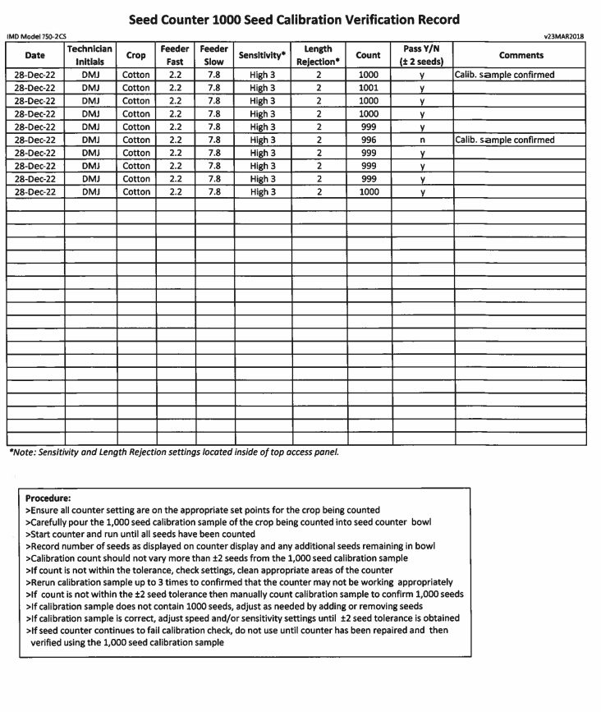
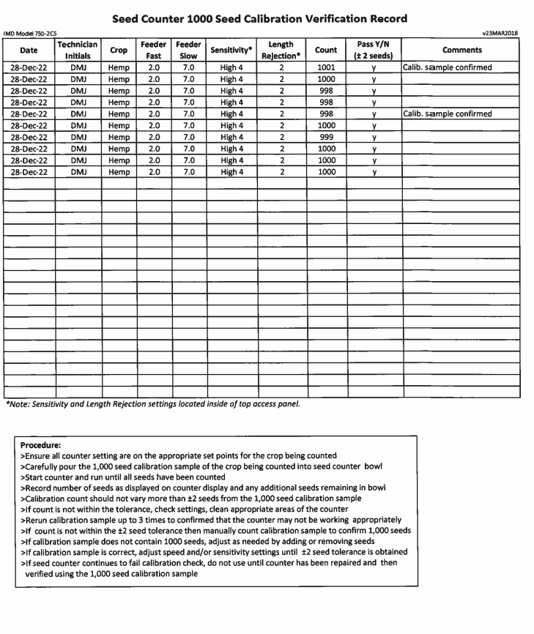
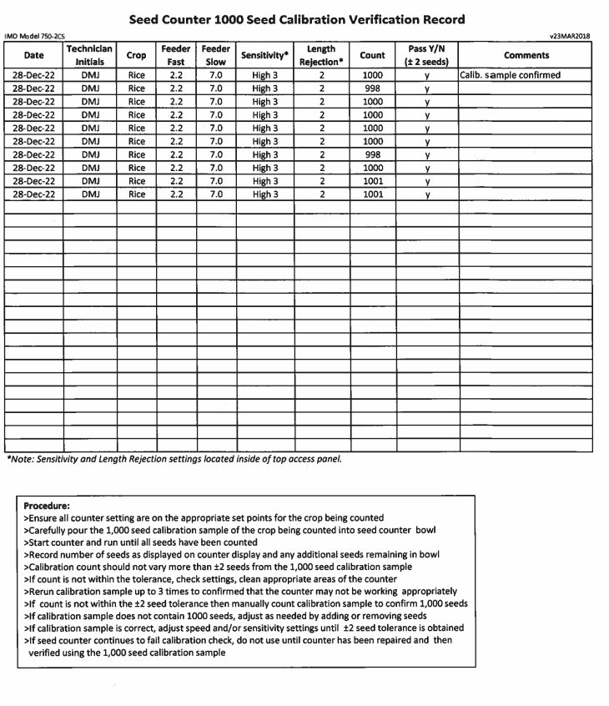
Mechanical Seed Counters Operation Manual Review:
The following mechanical seed counter information and operational manuals were briefly reviewed to determine if a 1,000 seed calibration sample was required or encouraged to be used to calibrate the device. While a few devices stated they had an automatic calibration and/or adjustment process, none of the manuals stated using a 1,000 seed calibration sample to confirm the accuracy of the device before use.
1. Wintersteiger Seed Counter S-25+
https://www.wintersteiger.com/us/Plant-Breeding-and-Research/Products/Product-range/Laboratory-preparation/66-Seed-Count-S-25plus
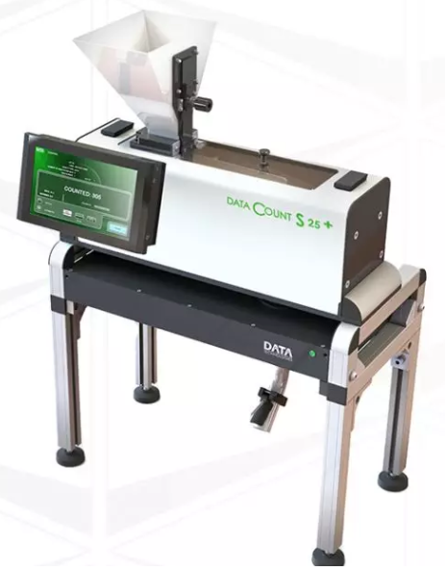
2. Agri-Instrument SLY-E High Accuracy Automatic Seed Counter
https://www.agri-instrument.com/wp-content/uploads/2018/05/SLY-E-High-Accuracy-Automatic-Seed-Counter.pdf
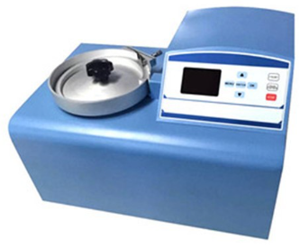

3. Data Technologies DATA Count S-25 Plus
https://data-technologies.com/wp-content/uploads/2017/09/Seed-Counter-S-25.pdf

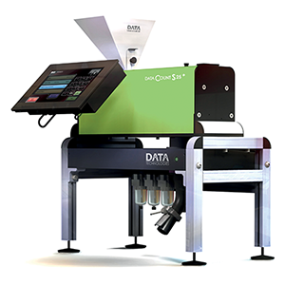

. Seedburo Count-A-Pak 801
https://cdn.shopify.com/s/files/1/0070/8041/1191/files/801_Manual.pdf?v=1614276180

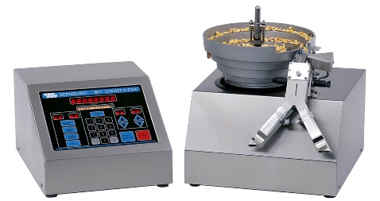

5. International Marketing and Design (IMD) Technologies Totalizer 750-2 C Series
http://www.seedcounters.com/index.php/counting/summary?id=148

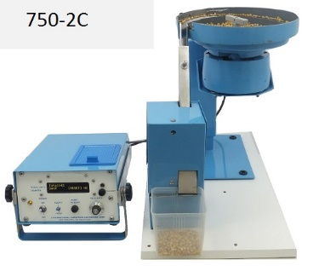

6. Pfeuffer Contador
https://www.pfeuffer.com/product/contador

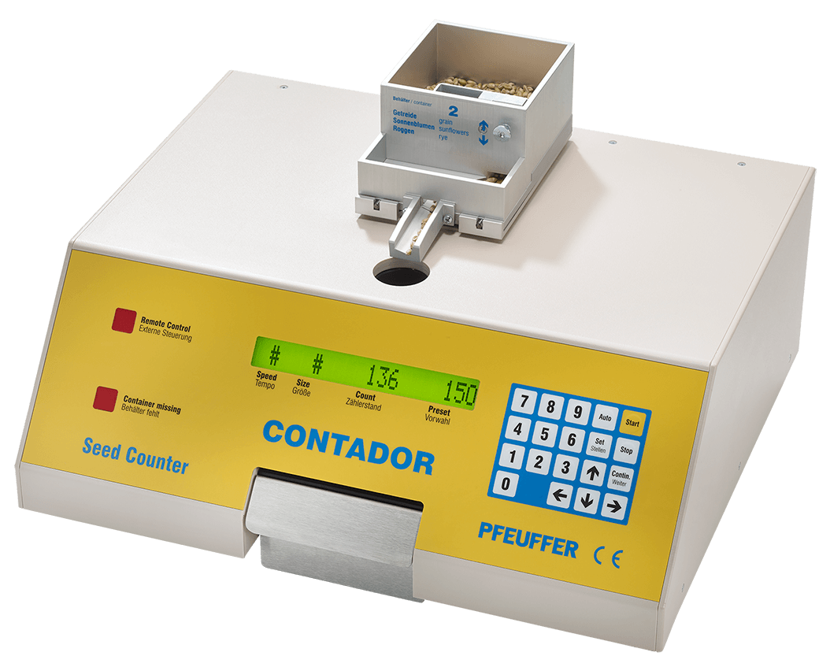

The submitter requested Voting status for this item in 2024.
Comments in Favor:
Regulatory:
- 2024 Interim: Mr. Paul Floyd, Louisiana, submitter stated that the item aligns with recently changed rules with AOSA. The rules were cut and pasted into the item and permission was received. They believe the item is ready for voting.
- 2024 Interim: Mr. Jim Willis, New York expressed support for this item as Voting.
Industry:
- None
Advisory:
- 2024 Interim: Mr. Loren Minnich, NIST OWM recommended this item for Voting. NIST received copyright permission for reprinting into Handbook 133.
Comments Against:
Regulatory:
- None
Industry:
- None
Advisory:
- None
Neutral Comments:
Regulatory:
- None
Industry:
- None
Advisory:
- None
Item Development:
NCWM 2024 Interim: All comments received during Open Hearings were in favor of the item. The Submitter informed the Committee that he had received copyright permission to reprint the item in NIST Handbook 133. The committee feels the item has merit and is fully developed and has assigned it Voting status.
Regional Associations’ Comments:
New Proposal
CWMA 2023 Interim: No comments were heard.

The committee recommends this item be informational for more comments to come in.
WWMA 2023 Annual: Matt Douglas, California Department of Food and Agriculture, Division of Measurement Standards stated he was not familiar with the testing procedure but was not against the proposal. Mr. Douglas was hoping for more discussion on this item.

The WWMA L&R Committee recommends this item be Informational.
SWMA 2023 Annual: The SWMA recommends a Voting status for this item pending copyright approval to be included into HB 133.

NEWMA 2023 Interim: Jim Willis, NY – New York has a seed lab, and the director of this lab is in favor of this being a Voting item.

Walt Remmert, PA – Concurs with NY.

Lou Sakin, Holliston, MA - Recommends it move forward as ‘Voting’ item.
The committee recommends this as a Voting item.
Additional letters, presentation and data may have been submitted for consideration with this item. Please refer to https://www.ncwm.com/publication-15 to review these documents.

OTH – OTHER ITEMS

OTH-24.1 A X. Uniform Shipping Law
Source: New Hampshire Weights and Measures

Purpose:
Provide model law language to address the shipment of goods.
Item under Consideration:
Adopt a new Handbook 130 Uniform Shipping Law as follows:
X. Uniform Shipment Law
Section 1. Purpose
The purpose of this Act is to ensure the accurate shipment of goods.
Section 2. Scope
This Act:
(a) establishes an enforcement program;
(b) empowers the state to promulgate regulations as needed to carry out the provisions of the Act;
(c) provides for civil and criminal penalties.
Section 3. Definitions
As used in this Act:
X.X. Goods
All things which are movable and can be transported.
X.X Carrier
The business that transports an amount of goods.
X.X Shipper
Individuals or businesses that send goods using a carrier.
X.X Shipment
A quantity of goods shipped with a carrier.
X.X. Freight
Goods or charges.
X.X. Freight Broker
The intermediary between the shipper and the carrier who facilitates the transportation of goods.
X.X. Quote
A competitively solicited written offer to furnish supplies or services by a method of procurement that is less formalized than a bid or a proposal.
X.X. Bill of Lading (BOL)
A legal instrument used in the transportation and shipping industries which lists the goods being shipped and the terms under which they will be delivered.
X.X. Progressive Number (Pro Number)
A series of numbers used by carriers to identify and then track a specific order tendered to a specific carrier.
X.X. Inspection Certificate
A document used to signify that shipped goods have been inspected pertaining, but not limited to, classification, density, weight, or measure.
X.X Director. – The __________ of the Department of __________.
Section 4. Enforcing officer: Rules and Regulations
The Director is authorized to:
(a) enforce the provisions of this Act;
(b) issue reasonable regulations for the enforcement of this Act that shall have the force and effect of law; and
(c) adopt rules that include, but are not limited to;
(1) adherence to quotes when correct documentation is provided to the carrier;
(2) weighing and measuring practices that must be followed;
(3) the required information to be submitted to the shipper if there is a correction fee applied; and
(4) the period of recordkeeping.
Section 5. Weighing and Measuring Practices and Equipment Used
A carrier shall use the following weighing and measuring practices and equipment:
(a) in accordance with the requirements of the latest edition of NIST Handbook 44, “Specifications, Tolerances, and Other Technical Requirements for Weighing and Measuring Devices”; and
(b) examined, tested, and approved for use by a weights and measures officer of this state.
Section 6. Weighing Device Used:
A carrier shall use a scale in accordance with the manufacturer’s approved application of the device.
Section 7. Measuring Device Used:
A carrier shall use a measuring device in accordance with the manufacturer’s approved application of the device.
Section 8. Inspection Certificate: Required Entries
(a) The documentation, when properly completed and signed shall be prima facie evidence of the accuracy of the procedure followed and the recorded results.
(b) The design of and the information to be furnished on the documentation shall be prescribed by the Director and will include, but not be limited to, the following:
(1) the name and employee ID# of the individual who conducts the inspection;
(2) date and time of the inspection;
(3) signature of the employee who conducts the inspection (digital signature accepted);
(4) identifying information of the weighing or measuring device used to conduct the inspection to include the associated make, model, serial number, and Certificate of Conformance number, if applicable;
(5) indicated reweigh or remeasure value from the weighing device or measuring device;
(6) provide detailed information on the process used to reclassify a shipment according to type of goods and/or shipment density;
(7) provide the dollar amount of the correction fee applied and the description of the fee;
(8) identifying information for the issuing terminal to include physical address and contact name of terminal manager to include phone number and/or email address;
(9) identifying information for both the Pro Number and BOL, if applicable;
(10) the name and address of the shipper from point of origin;
(11) the tendered classification, density, weight, or measurement provided from the shipper and freight broker, if applicable; and
(12) the declared classification, density, weight, or measurement determined by the carrier and freight broker, if applicable.
Section 9. Copies of Inspection Certificates
The carrier shall keep and preserve for the period specified in the regulations a legible copy of each inspection certificate issued to the shipper and freight broker, if applicable. The certificates shall be available for inspection by any weights and measures officer during normal office hours.
Section 10. Prohibited Acts
No entity shall
(a) provide a false classification, density, weight, or measurement;
(b) violate any provisions of this Act or any regulation promulgated under this Act; or
(c) use or have in their possession a device which has been altered to facilitate fraud.
Section 11. Civil Penalties
11.1. Assessment of Penalties. – Any entity who by themselves or by their servant or agent commits any of the acts enumerated in Section 14. Validity of Prosecutions may be assessed by the __________ a civil penalty of:
(a) not less than $ nor more than $ for a first violation,
(b) not less than $ nor more than $ for a second violation within from the date of the first violation, and
(c) not less than $ nor more than $ for a third violation within from the date of the first violation.
11.2. Administrative Hearing. – Any entity subject to a civil penalty shall have a right to request an administrative hearing within __________ days of receipt of the notice of the penalty. The Director or their designee shall be authorized to conduct the hearing after giving appropriate notice to the respondent. The decision of the Director shall be subject to appropriate judicial review.
11.3. Collection of Penalties. – If the respondent has exhausted their administrative appeals and the civil penalty has been upheld, they shall pay the civil penalty within __________ days after the effective date of the final decision. If the respondent fails to pay the penalty, a civil action may be brought by the Director in any court of competent jurisdiction to recover the penalty. Any civil penalty collected under this Act shall be transmitted to _________.
Section 12. Criminal Penalties
12.1. Misdemeanor. – Any entity who by themselves or by their servant or agent commits any of the acts enumerated in Section 10. Prohibited Acts or violates any other provision of this Act shall be guilty of a Class __________ misdemeanor and upon conviction shall be punished by a fine not less than $__________, nor more than $__________, or by imprisonment for not less than __________ nor more than __________, or both fine and imprisonment.
12.2. Felony. – Any entity who by themselves or their servant or agent who intentionally commits any of the acts enumerated in Section 1. Prohibited Acts or repeatedly violates any other provision of this Act shall be guilty of a Class __________ felony and upon conviction shall be punished by a fine not less than $__________ and/or by imprisonment for not less than __________, nor more than __________.
Section 13. Restraining Order and Injunction
The Director is authorized to apply to any court of competent jurisdiction for a restraining order, or a temporary or permanent injunction, restraining any person from violating any provision of this Act.
Section 14. Validity of Prosecutions
Prosecutions for violation of any provision of this Act are declared to be valid and proper notwithstanding the existence of any other valid general or specific Act of this state dealing with matters that may be the same as or similar to those covered by this Act.
Section 15. Severability Provision
If any provision of this Act is declared unconstitutional, or the applicability thereof to any person or circumstance is held invalid, the constitutionality of the remainder of the Act and the applicability thereof to other persons and circumstances shall not be affected.
Section 16. Repeal of Conflicting Laws
All laws and parts of laws contrary to or inconsistent with the provisions of this Act, and specifically __________, are repealed insofar as they might operate in the future; but as to offenses committed, liabilities incurred, and claims now existing there under, the existing law shall remain in full force and effect.
Section 17. Citation
This Act may be cited as the “Shipment Act of __________.”
Section 18. Effective Date
This Act shall become effective on __________.
Source:
New Hampshire Department of Agriculture, Markets & Food
Previous Status:
2024: New Proposal
Original Justification:
Current shipping practices may result in incorrect overcharges and misleading pricing. It has been documented through investigations that carriers or freight brokers have incorrectly billed shippers on goods shipped. Documentation provided by carriers to both shippers and weights and measures officials lack relevant information needed to fully investigate complaints within the shipping industry.
Carriers may have language in their contracts that inform the shipper of possible audits of their shipped goods and subsequent correction and audit fees.
The submitter requested Voting status in 2024.
Comments in Favor:
Regulatory:
- 2024 Interim: Mr. Doug Rathbun, Illinois applauded New Hampshire for the work done. He related an Amazon issue to illustrate the need for this item. Mr. Rathbun said he was willing to participate in a task group on the subject.
- 2024 Interim: Mr. Steven Harrington, Oregan echoed the concerns raised in the presentation. He stated that the package is held hostage based on the reweigh fee somewhere in the system. Mr. Harrington also relayed that Oregan has found a similar situation. He said he’d participate in a task group.
- 2024 Interim: Mr. Jason Flint, New Jersey said that his state has many issues with FedEx and other shippers. Mr. Flint recommended this item be assigned to a task group.
- 2024 Interim: Mr. Ethan Bogren, Westchester County New York said that the body would benefit from the expanded presentation from the Spring regional meetings to explain the issue with more depth.
- 2024 Interim: Dr. Matthew Curran, Florida said that the body should consider the forum and location for enforcement of this type of requirement. He also shared that perhaps it would be more appropriate if this item was within the Method of Sale.
- 2024 Interim: A regulator from Washington State Weights and Measures – Believes the motor carriers act covers the return of disputed property (must relinquish the property).
- 2024 Interim: Kurt Floren, County of Los Angeles – Supports the proposal to a task group for this item. Encourages NIST and U.S. Department of Commerce involvement. Can we assume these authorities (carriers act and who enforces it)? With whom do we need to coordinate. Identify any potential restrictions. Need federal involvement to make progress.
- 2024 Interim: Three other regulators supported forming a task group and would be willing to serve on it.
Industry:
- None
Advisory:
- 2024 Interim: Ms. Nathalie Campeau, Measurement Canada, stated that they were in accordance with the issue and volunteered to work on the task force.
Comments Against:
Regulatory:
- None
Industry:
- None
Advisory:
- None
Neutral Comments:
Regulatory:
- 2024 Interim: Ms. Cheryl Ayers, New Hampshire, submitted said that she appreciated all the comments and support. Ms. Ayers elaborated that she considered forming a task group from the beginning that will be able to look at the issue and determine the best ways to address it.
Ms. Ayers also shared a letter of support from Mr. Jim Hannon (retired from Roadway and 2022 lawsuit US vs. Roadway Express [YRC]). She asked for submission of letter on the NCWM website.
Industry:
- None
Advisory:
- None
Item Development:
NCWM 2024 Interim: The submitter made a presentation on this item and the Committee heard support for the item, but recognizing it is not fully developed will request to assign it to the newly formed Uniform Shipping Law Task Group.
Regional Associations’ Comments:
New Proposal
CWMA 2023 Interim: Mike Harrington, Iowa commented he does not fully understand the purpose of this item. He asks for clarification from the submitter. At this point he would recommend withdrawing the item because he doesn’t understand how it relates to weights and measures.
The committee recommends withdrawal. More information is needed to clarify the intent of this item.
WWMA 2023 Annual: Steven Harrington, State of Oregon stated that he had no preference in opposition or support for this item. Mr. Harrington stated we might run into a situation where we are getting into regulating interstate commerce, so this item needs to be vetted, possibly by a task group, to ensure we get the details right.
Matt Douglas, California Department of Food and Agriculture, Division of Measurement Standards echoed Mr. Harrington’s comments, with the additional statement that more input would be needed from impacted industries, and may need to be addressed by a task group. Mr. Douglas stated this should be a developing item.
Kurt Floren, County of Los Angeles, California echoed previous speakers, adding that there has been fraud for many, many years in this area, particularly in the moving industry, with no record of re-weighments, and possessions being held, so it would seem that something needs to be done. However, this would be stepping heavily into interstate commerce with little justification. Mr. Floren states there needs to be additional justification, and recommends this item be Informational and to call for broad nationwide input.
The WWMA L&R Committee recommends this item be Informational.
SWMA 2023 Annual: The SWMA L &R Committee does not see any merit in the language as provided and recommends this item be withdrawn.
NEWMA 2023 Interim: Cheryl Ayer, NH – Provide a presentation and Power Point slide deck to NEWMA. The expectation is to create rules for shipping (and reweighing) products nationwide. She is willing to participate or chair a task group.
Walt Remmert, PA - Recognizes this is a problem and thanks NH for taking on this issue. PA supports the item and has a volunteer to work on the task group if one is organized.
Lou Sakin, Holliston, MA - Commends NH for her presentation, Questions if this is an interstate commerce issue and which agencies need to get involved? Seeking help from other jurisdictions for input and help with these issues. Perhaps a task group is appropriate.
Jason Flint, NJ – Likes the idea and wants it to be further developed.
The committee recommends this item as a developing item.
Additional letters, presentation and data may have been submitted for consideration with this item. Please refer to https://www.ncwm.com/publication-15 to review these documents.

OTH-07.1 D Fuels and Lubricants Subcommittee
Source:
NCWM Fuels and Lubricants Subcommittee (FALS)
Purpose:
Provide an update of the activities of this Subcommittee which works on direction from and reports to the L&R Committee. The mission of FALS is to assist the L&R Committee in the development of agenda items that affect Handbook 130, Uniform Fuels and Automotive Lubricants Inspection Law and Uniform Fuels and Automotive Lubricants Regulation. The Subcommittee consists of regulators and associate members who have subject matter expertise in fuels and lubricants. The Subcommittee will be called upon to aid in the development, provide guidance, and help establish NCWM position on items concerning fuels and lubricants.
Item Development:

NCWM 2024 Interim: Ms. Vanessa Benchea, FALS Chair updated the Committee during Open Hearings on the FALS activities. Ms. Benchea also provided this written report to the Committee. This item is to provide a report on the activities of the Fuels and Lubricants Subcommittee (FALS), which reports and provides recommendations to the Laws and Regulations Committee.
For more information or to provide a comment please contact Ms. Vanessa Benchea, FALS Chair.
FALS met on Sunday, January 7, 2024, at the 2024 NCWM Interim Meeting in New Orleans, Louisiana to review items related to fuel and automotive fluid standards that appear on the L&R agenda. Assigned Block item 1, along with correspondence from a state regulator and multiple new business items were presented and discussed.
For Item Block 1 (B1) Renewable Diesel and Diesel, Chuck Corr (Chuck Corr Consulting) presented some additional changes to the latest proposed language developed by the Middle Distillate Focus Group. The Subcommittee felt these changes were editorial in nature and no further discussion or comments were received.
Correspondence from Walt Remmert (Pennsylvania) Walt Remmert, Pennsylvania, shared a recent issue from his state where small companies were “reclaiming” fuel from junkyards/scrapyards and selling it at small retail gasoline stations. While there is federal guidance that allows the use of such reclaimed fuel for equipment used in the junkyard/scrapyard where it originated there is limited guidance on “reselling” of such fuel offsite. While the fuel in Pennsylvania was sold as “Regular 87 octane gasoline” and had passed octane requirements there were concerns of the fuel being D4814 compliant, being transported in non-certified trucks and sold to non-branded stations in 200–1000-gallon increments, typically at half the cost of gasoline purchased at a terminal or bulk plant. Another state, North Carolina, shared a similar incident where once their department of revenue became involved the sale of the “reclaimed” fuel stopped. Walt shared that he was looking into the matter further and hopes to provide further information at the next meeting.
Streamline Efforts with SCE
Randy Jennings provided an update on the streamlining efforts in ASTM Subcommittee E which is officially considering combining D7467 (Standard Specification for Diesel Fuel Oil, Biodiesel Blends (B6-B20) and D975 (Standard Specification for Diesel Fuel).
Electric Vehicle Fluids Focus Group
With the dissolution of the Transmission Fluid Focus group, efforts to form a new group focusing on EV fluids will hopefully be underway in the upcoming year. Anyone interested in participating in this group was asked to reach out Vanessa Benchea or Johanna Johnson. Scott Fenwick (Clean Fuels Alliance America) also provided information on the new coordinating subcommittee at ASTM (D02-96) that will be a collection point for information and standard development for EV fluids and the first meeting for the group will take place at the D02 committee meeting in June.
During an open floor discussion, Randy Jennings raised an informal consideration regarding whether the Uniform Fuels and Automotive Lubricants Regulation should be split into two parts. Since many states may not be regulating all the products represented in Handbook 130 a separation of the more relevant product types might be helpful when states adopt the Handbook. Initial feedback from one state regulator indicated they would prefer to keep the Handbook in its current form. The group was asked if there were any additional thoughts on pursuing this to reach out to Randy Jennings or Vanessa Benchea.
ASTM D4814 Updates
Matt Sheehan (Chevron) presented updates on the changes that have been made to the volatility specifications in ASTM D4814. That presentation will be provided with the minutes and online. He will now also provide a brief overview of these changes.
Regional Associations’ Comments:

CWMA 2023: No comments were heard.

The committee recommends this remain developing.
WWMA 2023: No comments were heard on this item. The WWMA L&R Committee would like to thank FALS for their continued work and any report we may see in the future.

The WWMA L&R Committee recommends this as a Developing item.
SWMA 2023 Annual: No comments were heard from the floor. The committee recommends this remains as a developing item.

NEWMA 2023 Interim: No Comments
The committee recommends this as a developing item.

Additional letters, presentation and data may have been submitted for consideration with this item. Please refer to https://www.ncwm.com/publication-15 to review these documents.

OTH-11.1 D Packaging and Labeling Subcommittee
Source:
NCWM Packaging and Labeling Subcommittee (PALS)
Purpose:
Provide an update of the activities of this Subcommittee which reports to the L&R Committee. The mission of PALS is to assist the L&R Committee in the development of agenda item, NCWM positions and new standards related to packaging and labeling. The Subcommittee will also be called upon to provide important and much needed guidance to the regulatory and consumer packaging communities on difficult questions. PALS will report to NCWM L&R Committee. The Subcommittee is comprised of a Chair, eight voting members, and anyone interested in packaging and labeling standards.
Original Justification:
This item is to provide a report on the activities of the Packaging and Labeling Subcommittee which reports and provides recommendations to the Laws and Regulations Committee.
For more information or to provide comment, please contact the PALS Chair:
Mr. Chris Guay
CGGT
513-652-6597, guay.cb@gmail.com
PALS is comprised of four voting regulatory officials (one from each region) and four voting members from industry (retailers and manufacturers) in addition to its Chair and NIST Technical Advisor. Members of NCWM can participate in the PALS meetings by contacting Chair Guay. PALS work is being developed through monthly webinar meetings and at the NCWM meetings. PALS members are responsible for providing updates at their Regional Meetings. Chair Guay added PALS will be developing proposals and in addition providing guidance and recommendations on existing proposals as assigned by the NCWM L&R Committee. He stressed the importance of having key federal agencies (FDA, FTC, and USDA) participating.
Item Development:
NCWM 2024 Interim Meeting: Chairman Chris Guay updated the Committee on PALS activities stating that their Sunday session was an update. PALS is working on a best practice document projected to be done before the Annual meeting. It will be published in NCWM Publication 16, After publication they will take it to the Conference and go through the publication process. Items on the publication panel were put to the side as the group worked on E-Commerce.
Regional Associations’ Comments:
CWMA 2023 Interim Meeting: Chris Guay, PALS Chairperson provided an activity update and invited interested attendees to be active members of the committee. He reported PALS is working on an E-commerce document which should be available in January.
The committee recommends this remain developing.
WWMA 2023 Annual: No comments were heard on this item. The WWMA L&R Committee would like to thank PALS for their continued work and any report we may see in the future. The WWMA L&R Committee recommends this as a Developing item.
SWMA 2023 Annual: No comments were heard from the floor. The committee recommends this as a Developing item.
NEWMA 2023 Interim: No Comments. The Committee recommends this as a developing item.
Additional letters, presentation and data may have been submitted for consideration with this item. Please refer to https://www.ncwm.com/publication-15 to review these documents.

item block 1 (b1) V renewable diesel and diesel

Source:
FALS
Purpose:
Further refine the changes related to biodiesel made at the 2022 annual meeting. This proposal also includes needed updates related to renewable diesel.
Item under Consideration:
The most current version to amend Handbook 130, Uniform Regulation for the Method of Sale of Commodities as follows (previous versions can be found in Publication 15):

B1: MOS-23.1 V Sections 2.31. Biodiesel and Biodiesel Blends and 2.40. Diesel Fuel.

2.31. Biodiesel and Biodiesel Blends.
2.31.1. Identification of Product. – Biodiesel shall be identified by the term “Biodiesel” with the designation “B100.” Biodiesel Blends shall be identified by the term “Biodiesel Blend.”

2.31.2. Labeling of Retail Dispensers.
2.31.2.1. Labeling of Grade Required. – Biodiesel and biodiesel blends shall be identified in accordance with both EPA and FTC requirements.
2.31.2.2. Automotive Fuel Rating. – Biodiesel and biodiesel blends shall be labeled with its automotive fuel rating in accordance with 16 CFR 306.
2.31.2.3. Biodiesel Blends. –When biodiesel blends greater than 20 % by volume are offered by sale, each side of the dispenser where fuel can be delivered shall have a label conspicuously placed that states “Consult Vehicle Manufacturer Fuel Recommendations.” The lettering of this legend shall not be less than 6 mm (¹/₄ in) in height by 0.8 mm (¹/₃₂ in) stroke; block style letters and the color shall be in definite contrast to the background color to which it is applied.
2.31.3. Documentation for Dispenser Labeling Purposes. The retailer shall be provided, at the time of delivery of the fuel, a declaration of the volume percent biodiesel on an invoice, bill of lading, shipping paper, or other document. This documentation is for dispenser labeling purposes only; it is the responsibility of any potential blender to determine the amount of biodiesel in the diesel fuel prior to blending.
2.31.4. Exemption. – Biodiesel blends that contain less than or equal to 5 % biodiesel by volume are exempt from the requirements of Sections 2.31.1. Identification of Product, 2.31.2. Labeling of Retail Dispensers, and 2.31.3. Documentation for Dispenser Labeling Purposes when it is sold as diesel fuel.
(Added 2008) (Amended 2022)
2.40. Diesel Fuel. – Shall meet the following requirements, based on the biodiesel concentration of the fuel:
(a) Diesel fuel that contains less than or equal to 5 % by volume biodiesel shall meet the latest version of ASTM D975, “Standard Specifications for Diesel Fuels” and shall be sold as diesel fuel.
(b) Diesel fuel that contains biodiesel in concentrations greater than or equal to 6 % by volume biodiesel and that contains less than or equal to 20 % by volume shall meet the latest version of ASTM D7467, “Standard Specifications for Diesel Fuel Oil, Biodiesel Blend (B6 to B20).” (Amended 20XX)
(c) Diesel fuel that contains greater than or equal to 21 % by volume biodiesel shall be a blend of fuel from (a) or (b) and biodiesel meeting the latest version of ASTM D6751, “Standard Specification for Biodiesel Fuel Blend Stock (B100) for Middle Distillate Fuels.” (Added 20XX)
(d) Only fuel additives registered with the U.S. EPA may be used to additize diesel fuel, and the final product shall meet the latest version of ASTM D975 and/or ASTM D7467. (Added 20XX)
2.40.1. Labeling of Retail Dispensers.
2.40.1.1. FTC Automotive Fuel Rating. – Diesel fuel shall be labeled with its automotive fuel rating in accordance with Automotive Fuel Ratings, Certification and Posting Rule 16 C.F.R. 306.
2.40.1.2. Biodiesel Concentrations of 21% or Greater - When diesel fuel that contains biodiesel concentrations greater than or equal to 21 % by volume is offered by sale, each side of the dispenser where fuel can be delivered shall have a label conspicuously placed that states “Consult Vehicle Manufacturer Fuel Recommendations.” The lettering of this legend shall not be less than 6 mm (¹/₄ in) in height by 0.8 mm (¹/₃₂ in) stroke; block style letters and the color shall be in definite contrast to the background color to which it is applied.
2.40.1.3. Documentation for Dispenser Labeling Purposes. –The retailer shall be provided, at the time of delivery of the fuel, a declaration of the volume percent biodiesel and or volume percent of biomass-based diesel on an invoice, bill of lading, shipping paper, or other documents. This documentation is for dispenser labeling purposes only; it is the responsibility of any potential blender to determine the amount of biodiesel in the diesel fuel prior to blending.
2.40.1.4. Delivery Documentation for Premium Diesel or Other Diesel Terminology Claims. – Before or at the time of delivery of the diesel fuel, the retailer or the wholesale purchaser-consumer shall be provided on an invoice, bill of lading, shipping paper, or other documentation a declaration of all performance properties that qualifies the fuel as premium diesel fuel as required in Section 2.40.2. Premium Diesel Fuel and 2.40.3. Use of Other Diesel Terminology.
(Added 20XX)
2.40.2. 2.40.1. Premium Diesel Fuel. – All diesel fuels identified on retail dispensers as premium, super, supreme, or premier must conform to the following minimum requirements.
(a) Cetane Number. – A minimum cetane number of 47.0 as determined by the latest version of ASTM D613, “Standard Test Method for Cetane Number of Diesel Fuel Oil.”
NOTE: ASTM D613, “Standard Test Method for Cetane Number of Diesel Fuel Oil” is the referee method; however, the following methods can be used to determine cetane number: the latest version of ASTM D6890, “Standard Test Method for Determination of Ignition Delay and Derived Cetane Number” (DCN) of Diesel Fuel Oils by Combustion in a Constant Volume Chamber”; and ASTM D7668, “Standard Test Method for Determination of Derived Cetane Number (DCN) of Diesel Fuel Oils–Ignition Delay and Combustion Delay Using a Constant Volume Combustion Chamber Method.”
(b) Low Temperature Operability. – A cold flow performance measurement which meets the latest version of ASTM D975, “Standard Specification for Diesel Fuel,” tenth percentile minimum ambient air temperature charts and maps by the latest version of either ASTM D2500, “Standard Test Method for Cloud Point of Petroleum Products and Liquid Fuels” or ASTM Standard D4539, “Standard Test Method for Filterability of Diesel Fuels by Low-Temperature Flow Test (LTFT).” The latest version of ASTM D6371, “Standard Test Method for Cold Filter Plugging Point of Diesel and Heating Fuels” may be used when the test results are a maximum of 6 °C below the Cloud Point. Low temperature operability is only applicable October 1 to March 31 of each year.
(c) Lubricity. – A maximum wear scar diameter of 460 micrometers as determined by the latest version ASTM D6079, “Standard Test Method for Evaluating Lubricity of Diesel Fuels by the High-Frequency Reciprocating Rig (HFRR).”
NOTE: The latest version of ASTM D6079, “Standard Test Method for Evaluating Lubricity of Diesel Fuels by the High-Frequency Reciprocating Rig (HFRR)” is the referee method; however, the latest version of ASTM D7688, “Standard Test Method for Evaluating Lubricity of Diesel Fuels by the High-Frequency Reciprocating Rig (HFRR) by Visual Observation” can be used.
(d) Corrosion. – A minimum rating of B+ as determined by the most recent version of NACE TM0172, “Determining Corrosive Properties of Cargoes in Petroleum Product Pipelines.”
NOTE: The latest recent version of NACE TM0172 “Determining Corrosive Properties of Cargoes in Petroleum Product Pipelines” is the referee method. The latest version of ASTM D7548 “Standard Test Method for Determination of Accelerated Iron Corrosion in Petroleum Products” can be used.
(e) Filter Blocking Tendency (FBT) – A maximum of 2.2 by the latest version of ASTM D2068, “Standard Test Method for Determining Filter Blocking Tendency”, following procedure B.
(f) Injector Deposit Control. – Maximum power loss in a keep-clean mode of 2 % by the latest version of Coordinating European Council, CEC F-98-08, “Direct Injection, Common Rail Diesel Engine Nozzle Coking Test.”
(Amended 20XX)
2.40.3. 2.40.2. Use of Other Diesel Terminology – For any terms other than premium, super, supreme, or premier included in the diesel fuel product or grade name and/or advertisements and claims displayed on dispensers, pump toppers, pole signs, and bollard signs which imply improved performance, the product must have a clearly-defined fuel property with a substantiated functional benefit. Such property must be measurable utilizing industry-accepted test methodologies developed by recognized standards organizations such as ASTM, SAE, and CEC to allow verification of the improved performance.
(Added 2021) (Amended 20XX)

B1: FLR-23.1 V Sections 1.9. Biodiesel Blend., 1.15. Diesel Fuel., 1.27. Fuel Oil., 2.2. Diesel Fuel., 3.3. Diesel Fuel., and 3.15. Biodiesel and Biodiesel Blends.
Item Under Consideration:
Amend the Uniform Fuels and Automotive Lubricants Regulation as follows:
B1:FLR-23.1
F. Uniform Fuels and Automotive Lubricants Regulation

Section 1. Definitions
1.9. Biodiesel Blend – A fuel comprised of a homogeneous mixture of hydrocarbon oils and mono-alkyl esters of long-chain fatty acids. a blend of biodiesel with hydrocarbon diesel fuel.
(Amended 2018 and 20XX)
1.15. Diesel Fuel – A refined hydrocarbon suitable for use as a fuel in a compression-ignition (diesel) internal combustion engine that may contain a combination of biodiesel, renewable diesel, and fuel additives. A liquid fuel specifically designed for injection into a compression-ignition engine to provide energy, commonly composed of hydrocarbons refined from petroleum or biomass and the fuel may contain biodiesel and fuel additives.
(Amended 2018 and 20XX)
1.27. Fuel Oil. – Refined oil middle distillates, heavy distillates, or residues of refining, or blends of these, suitable for use as a fuel for heating or power generation A liquid fuel designed for use in open flame applications to provide energy, commonly composed of hydrocarbons refined from petroleum or biomass and the fuel may contain biodiesel and fuel additives. The fuel may also be used in select compression-ignition engines.
(Amended 2018 and 20XX)

Section 2. Standard Specifications
2.2. Diesel Fuel. – Shall meet the following requirements, based on the biodiesel concentration of the fuel:
- Diesel fuel that contains less than or equal to 5 % by volume biodiesel shall meet the latest version of ASTM D975, “Standard Specifications for Diesel Fuels” and shall be sold as diesel fuel.
- Diesel fuel that contains biodiesel in concentrations greater than or equal to 6 % by volume biodiesel and that contains less than or equal to 20 % by volume shall meet the latest version of ASTM D7467, “Standard Specifications for Diesel Fuel Oil, Biodiesel Blend (B6 to B20).”
- Diesel fuel that contains greater than or equal to 21 % by volume biodiesel shall be a blend of fuel from (a) or (b) and biodiesel meeting the latest version of ASTM D6751, “Standard Specification for Biodiesel Fuel Blend Stock (B100) for Middle Distillate Fuels.”
- Only fuel additives registered with the U.S. EPA may be used to additize diesel fuel, and the final product shall meet the latest version of ASTM D975 and/or ASTM D7467.
(Amended 2003, and 2018, and 20XX)

Section 3. Classification and Labeling for Sale
3.3. Diesel Fuel.
3.3.1. Labeling of Grade Required. – Diesel Fuel other than No 2-D shall be identified by grade. Retail Dispensers.
3.3.1.1. FTC Automotive Fuel Rating. – Diesel fuel shall be labeled with its automotive fuel rating in accordance with Automotive Fuel Ratings, Certification and Posting Rule 16 C.F.R. 306.
3.3.1.2. Biodiesel Concentrations of 21% or Greater – When diesel fuel that contains biodiesel concentrations greater than or equal to 21 % by volume is offered by sale, each side of the dispenser where fuel can be delivered shall have a label conspicuously placed that states “Consult Vehicle Manufacturer Fuel Recommendations.” The lettering of this legend shall not be less than 6 mm (¹/₄ in) in height by 0.8 mm (¹/₃₂ in) stroke; block style letters and the color shall be in definite contrast to the background color to which it is applied.
3.3.1.3. Labeling of Grade Required. – Diesel Fuel other than No 2-D shall be identified by grade.
(Added 20XX)
3.3.2. Documentation for Dispenser Labeling Purposes. Automotive Fuel Rating. –Diesel fuel containing 6 % to 20 % by volume biodiesel shall be labeled with its automotive fuel rating in accordance with the FTC “Automotive Fuel Ratings, Certification and Posting Rule,” 16 CFR 306.
3.3.2.1. The retailer shall be provided, at the time of delivery of the fuel, a declaration of the volume percent biodiesel and or volume percent of biomass-based diesel on an invoice, bill of lading, shipping paper, or other documents. This documentation is for dispenser labeling purposes only; it is the responsibility of any potential blender to determine the amount of biodiesel in the diesel fuel prior to blending.
(Added 2018) (Amended 20XX)
3.3.2.2. 3.3.3. Delivery Documentation for Premium Diesel or Other Diesel Terminology Claims. –Before or at the time of delivery of the premium diesel fuel, the retailer or the wholesale purchaser-consumer shall be provided on an invoice, bill of lading, shipping paper, or other documentation a declaration of all performance properties that qualifies the fuel as premium diesel fuel as required in Section 2.2.1. Premium Diesel Fuel and 2.2.2 Use of Other Diesel Terminology.
(Added 1998) (Amended 1999 and 20XX)
(Amended 1998, 1999, 2008, 2012, and 2018, and 20XX)
3.15. Biodiesel and Biodiesel Blends
3.15.1. Identification of Product. – Biodiesel Blendstock shall be identified by the term “biodiesel” with the designation “B100” or “B99.”
(Amended 2018)
3.15.2. Labeling of Retail Dispensers.
3.15.2.1. Labeling of Grade Required. – Biodiesel shall be identified by the grades No. 1-B S15 or No. 1-B S500, or No. 2-B S500.
(Amended 2018)
3.15.2.2. Automotive Fuel Rating. –Biodiesel and biodiesel blends shall be labeled with its automotive fuel rating in accordance with the FTC Automotive Fuel Ratings, Certification and Posting Rule, 16 CFR 306.
(Amended 2018)
3.15.2.3. Biodiesel Blends. – When biodiesel blends greater than 20 % by volume are offered by sale, each side of the dispenser where fuel can be delivered shall have a label conspicuously placed that states “Consult Vehicle Manufacturer Fuel Recommendations.”
The lettering of this legend shall not be less than 6 mm (¹/₄ in) in height by 0.8 mm (¹/₃₂ in) stroke; block style letters and the color shall be in definite contrast to the background color to which it is applied.
3.15.3. Documentation for Dispenser Labeling Purposes. – The retailer shall be provided, at the time of delivery of the fuel, a declaration of the volume percent biodiesel on an invoice, bill of lading, shipping paper, or other document. This documentation is for dispenser labeling purposes only; it is the responsibility of any potential blender to determine the amount of biodiesel in the diesel fuel prior to blending.
3.15.4. Exemption. – Biodiesel blends that contain less than or equal to 5 % biodiesel by volume are exempted from the requirements of Sections 3.15.1. Identification of Product, 3.15.2. Labeling of Retail Dispensers, and 3.15.3. Documentation for Dispenser Labeling Purposes when it is sold as “diesel fuel” as required in Section 3.3. Diesel Fuel.
(Added 2005) (Amended 2008 and 2018)
Previous Action:
2023: Assigned – Fuels and Lubricants Subcommittee
Original Justification:
The proposed changes provide additional clarity to changes made related to biodiesel approved at the 2022 annual meeting. The proposal also includes important information related to renewable diesel. The submitter recognizes that some may think no changes are needed.
Comments in Favor:
Regulatory:
- 2024 Interim: Ms. Vanessa Benchea, FALS Chair: FALS agrees with Mr. Corr and believes the language change is editorial and the item is ready for Voting.
- 2024 Interim: Mr. Kevin Schnepp, California stated that California does not allow this technology, but he does support this item.
Industry:
- 2024 Interim: Mr. Chuck Corr, Chuck Corr Consulting representing Iowa Renewable Fuels Association developed and offered a change sheet posted on the NCWM website December 2023. He noted additional editorial changes. The item is ready for Voting.

- 2024 Interim: Mr. Scott Fenwick, Clean Fuels Alliance America, supported Chuck Corr’s proposal as amended with the editorial changes and recommends Voting.
- 2024 Interim Ms. Kristy Moore, Growth Energy, supported the item as Voting.
- 2024 Interim Mr. Randy Jennings, Clean Fuels Alliance America, expressed that this lack of ASTM standard for mid-blends has been addressed in the past with ethanol. Blends created with diesel fuel meeting an ASTM specification and B-100 meeting an ASTM specification will create quality biodiesel blends.
Advisory:
- None

Comments Against:
Regulatory:
- None

Industry:
- None

Advisory:
- None

Neutral Comments:
Regulatory:
- 2024 Interim: Mr. Matt Douglas, California Division of Measurement Standards, expressed concerns of no ASTM standard for biodiesel blends between B-20 and B-99. This proposal could make one believe that there is a standard

Industry:
- 2024 Interim: Mr. Scott Fenwick, Clean Fuels Alliance America, these biodiesel blends have been in the marketplace for many years. ASTM is working on a specification for mid-level blends of biodiesel greater than 20%.
Advisory:
- None

Item Development:
NCWM 2024 Interim: The Committee hearing support from Regulators, FALS and Industry believes this item to be fully developed and assigned Voting status to it.
NCWM 2023 Annual: The Committee agreed to include Mr. Corr’s new language in its Carry Over report for consideration by the Regional Associations. It will also be published in NCWM Publication 15.
The new language follows the Regional Associations comments as they pertain to the previous version of the item.
Regional Associations’ Comments:
WWMA 2022 Annual: Rebecca Richardson, Clean Fuels Alliance America, supports continued development of this item.
Mr. Kevin Schnepp of CDFA/DMS proposed several changes:
2.31.1. There are no current ASTM fuel quality standards for biodiesel and diesel blends greater than 20%. This section would imply that there is.
Deletion of 2.31.2.2 I do not see a need for this deletion.
Deletion of 2.31.4. Exemption. I do not see a need for this deletion. This section clarifies that biodiesel, diesel blends less than 5 % as considered diesel fuel.
Addition of 2.40.3 Labeling requirements: The FTC is covered in 2.31.2.2. If that section is deleted, then this requirement would be necessary.
B1: FLR-23.1
1.9. Biodiesel Blend. There are no current ASTM fuel quality standards for biodiesel, diesel blends greater than 20%. This section would imply that there is.
1.27 Fuel Oil. This is consistent with ASTM D396
1.XX Renewable Diesel. This is a weak definition that needs to be worked on.
3.3.2. Automotive Fuel Rating. – This is consistent with 16CRF306
3.15. Biodiesel and Biodiesel Blends containing greater than 20% by volume biodiesel. This is attempting to establish biodiesel blends greater than 20% by volume.
3.15.2.1. Labeling of Grade Required. This Fixes a miss B-2 S15 grade label.
3.15.2.2. Automotive Fuel Rating. This is the FTC requirement.
3.15.2.3. Biodiesel Blends. This section was not modified but I recommend that it be removed as there is no fuel quality standard for greater than 20% biodiesel, diesel blends.
3.15.4. Exemption. – This is consistent with 16CFR306
Based on testimony heard regarding this item not being fully developed, the WWMA L&R Committee recommends this item be assigned Developing status.
SWMA 2022 Annual: Mr. Randy Jennings (Clean Fuels) commented that he is generally in support of the items submitted and would like to see it go forward in some fashion. Speaking on his own behalf, he would like to suggest an amendment to the definition for diesel fuel to align with the recently updated ASTM D975.
Mr. Joe Sorena (Chevron) recommends the item remain in development and L&R consider alternate wording proposed concerning the concept of redefining the bio diesel blend containing greater than 20 %, as it is inconsistent with D7467 and will contribute to customer confusion.
Dr. Matthew Curran (Florida) commented he spoke with Chuck Corr regarding this item. Conceptually, approves this section. Inconsistencies were described found in the titles of MOS-23.1 and FLR-23.1 and a recommendation for clearer titles was made. He recommends in 2.31.2.1 verbiage is added to the specific EPA and FTC requirements.
Mr. Randy Jennings (Clean Fuels) suggested forming a focus group within FALS with Chuck Corr to lead and move this item forward.
The Committee corrected the title as follows:
B1: MOS-23.1 D Sections 2.231. Biodiesel and biodiesel Blends that Contain Greater Than or Equal to 21% by Volume Biodiesel. and 2.40. Diesel Fuel.
The Committee agrees that this item needs more development and recommends this as a Developing Item on the NCWM Agenda.
CWMA 2023 Annual Meeting: The CWMA recommended as an Assigned Item on the NCWM agenda.
Mr. Chuck Corr, Iowa Renewable Fuels Association, commented that the item is assigned to FALS which has formed a focus group that will make a presentation in July at the FALS meeting.
NEWMA 2023 Annual Meeting: Ms. Rebecca Richardson, Clean Fuels Alliance America offered an update on behalf of FALS stating that Chuck Corr, Chuck Corr Consulting, will have an update ready for the NCWM annual meeting in July. The NEWMA recommended as an Assigned Item on the NCWM agenda.
CWMA 2023 Interim: Chuck Corr, Iowa Renewable Fuels Association commented that this block was Assigned to FALS. The item has been updated, and the focus group will reconvene in November. He expects the final version by January 2024 and intends for the item to achieve Voting status. Mr. Corr further commented that this is found in Labeling of Retail Dispensers 2.40.1.3 L&R page 158, line 12, the word “renewable” should be replaced with “biomass-based”. Similarly, on Documentation for Dispenser Labeling Purposes 3.3.2.1 L&R page 162, line 32 the same correction should be made. This change is to keep the item consistent with Federal Trade Commission terminology.

The committee recommends this item remain assigned to FALS.
WWMA 2023 Annual: Randy Jennings, representing Clean Fuels Alliance America and FALS Vice Chair, supports this item moving forward, and has been working closely with Chuck Corr, submitter and the focus group. Mr. Jennings stated that the FALS Subcommittee gave no dissent to this item and posed no opposition to this item moving forward in July.
Mr. Corr submitted the following updates by email to the L&R Committee:
“These two items were assigned to FALS at the last interim meeting. During the spring a focus group refined the proposal and presented it to all FALS members at the July national meeting. There was consensus to publish this version to get additional feedback from the fall regional meetings. The focus group will reconvene in November to consider the feedback received. We will then present it for full FALS review. We expect a final version at the January Interim Meeting and hope for a voting status.
During the development process the focus group received a number of comments that, where the FTC regulation is being implemented, we should use FTC terminology. The FTC regulations use the term biomass-based diesel. The intention was to replace renewable diesel with biomass-based diesel throughout the proposal. When preparing the final document, I made an error by not making the replacement in two locations. Please consider these two corrections:
- Page L&R 158 Line 12 replace the word “renewable” with “biomass-based”
- Page L&R 162 Line 32 replace the word “renewable” with “biomass-based””
Steven Harrington, State of Oregon stated that he was in support of the proposal and encourages Voting status, as it is working to match language in 16 CFR part 306.
Kurt Floren, County of Los Angeles, California expressed that Mr. Jennings is the premier expert on this topic. Mr. Floren also asked if there was a reason for the discrepancy between the 20% and 21% throughout the document. Mr. Jennings replied that when measuring these quantities, the general rules of rounding would be applied.
Kevin Schnepp, California Department of Food and Agriculture, Division of Measurement Standards stated that he understood that the discrepancies may be due to a rounding issue, however the gap between 20% and 21% may cause enforcement issues. Mr. Schnepp recommended this item remain assigned to FALS.
Joe Sorena, Chevron, Russ Lewis, Marathon Petroleum, and Bill Striejewske, Nevada all stood in support of this item moving forward with the amendments as stated.
The WWMA L&R Committee recommends this item remain assigned to FALS until the final report is given by FALS in January, when this item may be escalated to Voting status.
SWMA 2023 Annual: The following update was provided by Vanessa Benchea, State of Florida, FALS Chair:
These two items were assigned to FALS at the last interim meeting. During the spring, a focus group refined the proposal and presented it to all FALS members at the July national meeting. There was consensus to publish this version to get additional feedback from the fall regional meetings. This language can be found on page L & R 157 of the agenda.
The focus group will reconvene in November to consider the feedback received. We will then present it for full FALS review.
We expect a final version at the January Interim Meeting and hope for a voting status.
During the development process the focus group received a number of comments that, where the FTC regulation is being implemented, we should use FTC terminology. The FTC regulations use the term biomass-based diesel. The intention was to replace renewable diesel with biomass-based diesel throughout the proposal. When preparing the final document, an error was made by not making the replacement in two locations. Please consider these two corrections:
- Page L&R 158 Line 12 replace the word “renewable” with “biomass-based”
- Page L&R 162 Line 32 replace the word “renewable” with “biomass-based”
Apologies for this error.
Again, we are looking for feedback on the proposal. You can either contact Chuck at chuckcorrconsulting@gmail.com or any FALS member.
Randy Jennings representing Clean Fuels and Russ Lewis, Marathon, both made comments in support of this item and the changes suggested.
The SWMA L&R Committee recommends this item remain assigned to FALS until the final report is given by FALS in January, when this item may be escalated to Voting status.
NEWMA 2023 Interim Meeting: Jim Willis, NY - Finds the wording confusing (21% in the title vs. references to 20% in the language) in the proposal, questioning transparency of renewable fuels with threshold of 20% and 21%.
Walt Remmert, PA - Supports this as a ‘Voting’ item.
The committee recommends this as a developing item.
Additional letters, presentation and data may have been submitted for consideration with this item. Please refer to https://www.ncwm.com/publication-15 to review these documents.

item block 2 (b2) Reference ASTM Standards D8080 and D8487

B2: FLR-24.2 V 2.9. Liquefied Natural Gas (LNG) Vehicle Fuel., 2.10. Compressed Natural Gas (CNG)., and 2.XX. Compressed Natural Gas (CNG) Blended with Hydrogen
Source:
AMT Consulting
Purpose:
Amend NIST HB 130 B. Uniform Regulation for the Method of Sale of Commodities: sections 2.9 and 2.10 by replacing SAE J1616 and SAE J2699 with ASTM D8080 “Standard Specification for Compressed Natural Gas (CNG) and Liquefied Natural Gas (LNG) Used as a Motor Vehicle Fuel.”

Amend NIST HB 130 B. Uniform Regulation for the Method of Sale of Commodities, Section 2 by adding a new paragraph for ASTM D8487 “Standard Specification for Natural Gas, Hydrogen Blends for Use as a Motor Vehicle Fuel.”.

Amend NIST HB 130 F. Uniform Fuels and Automotive Lubricants Regulation sections 3.10 and 3.11 by adding labeling of grades to the method of sale for CNG and LNG.
Item under Consideration:
Amend the Uniform Fuels and Automotive Lubricants Regulation as follows:
2.9. Liquefied Natural Gas (LNG) Vehicle Fuel. – Shall meet the latest version of SAE J2699, “Liquefied Natural Gas (LNG) Vehicle Fuel.” ASTM D8080 “Standard Specification for Compressed Natural Gas (CNG) and Liquefied Natural Gas (LNG) Used as a Motor Vehicle Fuel.”
2.10. Compressed Natural Gas (CNG). – Shall meet the latest version of SAE J1616, “Recommended Practice for Compressed Natural Gas Vehicle Fuel.” ASTM D8080 “Standard Specification for Compressed Natural Gas (CNG) and Liquefied Natural Gas (LNG) Used as a Motor Vehicle Fuel.”
2.XX Compressed Natural Gas (CNG) blended with hydrogen. Shall meet the latest version of ASTM D8487 “Standard Specification for Natural Gas, Hydrogen Blends for Use as a Motor Vehicle Fuel.”
Previous Status:
New in 2024

B2: FLR-24.1 V 3.11.2.1.X. Identification of Grade. and 3.12.2.X. Identification of Grade.
Item under Consideration:
Amend the Uniform Fuels and Automotive Lubricants Regulation as follows:
3.11.2.1.4. Identification of Grade. – Each retail dispenser of CNG shall be labeled with an identification of the grade of the product.
3.12.2.2. Identification of Grade. – Each retail dispenser of LNG shall be labeled with an identification of the grade of the product.
Previous Status:
New in 2024
Original Justification:
ASTM Committee D03 on Gaseous Fuels has adopted two new fuel quality specifications for natural gas vehicles:
ASTM D8080 “Standard Specification for Compressed Natural Gas (CNG) and Liquefied Natural Gas (LNG) Used as a Motor Vehicle Fuel”
ASTM D8487 “Standard Specification for Natural Gas, Hydrogen Blends for Use as a Motor Vehicle Fuel”.
These specifications are a replacement for both SAE J1616 (CNG) and SAE J2699 (LNG).
ASTM D8080 is intended for natural gas vehicle fuels that have no additional hydrogen blend in the fuel. The specification establishes performance grades based on the fuel resistance to engine knock, energy content, and sulfur levels.
ASTM D8487 is intended for natural gas vehicle fuels that have additional hydrogen blended in the fuel. The specification covers natural gas fuels that have been blended with hydrogen and establishes performance grades based on the fuel resistance to engine knock, energy content, and sulfur levels. This specification is to be used in locations where hydrogen is being blended into the natural gas supply. This will become increasingly important as the natural gas supply has hydrogen blended to meet the decarbonization efforts of the US.
Both these standards are applicable at the point of dispensing into the vehicle fuel tank.
This proposal will require dispensers to be labeled with the product grade. This will require the product composition to be determined.
The submitter requested that the status be “Developing”.
Comments in Favor:
Regulatory:
- 2024 Interim: Mr. Kevin Schnepp, California Department of Food and Agriculture, Division of Measurement Standards: Mr. Schnepp stated that CNG blending with hydrogen is already occurring in California. Mr. Schnepp stated that he agrees with the NIST OWM recommends, and that these recommendations should be incorporated, and the item given a Voting status.

Industry:
- None
Advisory:
- None
Comments Against:
Regulatory:
- None
Industry:
- None
Advisory:
- None
Neutral Comments:
Regulatory:
- 2024 Interim: Mr. Loren Minnich, NIST OWM: Mr. Minnich cited the NIST OWM Analysis of the Agenda, stating that the Item under Consideration, MOS-24.1, cites the incorrect regulation, and should be an FLR series item. Mr. Minnich also re-stated that this proposal replaces SAE standards with an ASTM standard. The NIST OWM recommends this item as Developing.
Industry:
- None
Advisory:
- None
Item Development:
NCWM 2024 Interim Meeting: The Committee did not hear support or opposition for the item, but recognized it has merit, and assigned Voting status. The Committee worked with the NCWM to correct the incorrect citation issued raised by NIST OWM.

Regional Associations’ Comments:
New Proposal
CWMA 2023 Interim Meeting: No comments were heard.

The committee recommends this item be developing status as requested by the submitter.
WWMA 2023 Annual Meeting: Kevin Schnepp, California Department of Food and Agriculture, Division of Measurement Standards stood in support of both items in Block 2. Mr. Schnepp stated that the ASTM standard that is specified in this item has been thoroughly vetted and is also a standard the accounts for hydrogen blending in natural gas, which is already adopted in Europe. Mr. Schnepp stated that these specifications meet the needs of industry and producers.
The WWMA L&R Committee recommends this item as Developing as requested by the submitter.
SWMA 2023 Annual Meeting: The SWMA L & R committee recommends this item as Developing as requested by the submitter. The committee would also like to alert NCWM that some items listed in Block 2 are referenced incorrectly to the Method of Sale of Commodities section and should reference the Fuels and Automotive Lubricants Regulation section and are listed below:
MOS-24.1 to FLR-24.#
Amend NIST HB 130 B. Uniform Regulation for the Method of Sale of Commodities F. Uniform Fuels and Automotive Lubricants Regulation: sections 2.9 and 2.10 by replacing SAE J1616 and SAE J2699 with ASTM D8080 “Standard Specification for Compressed Natural Gas (CNG) and Liquefied Natural Gas (LNG) Used as a Motor Vehicle Fuel.”
Amend NIST HB 130 B. Uniform Regulation for the Method of Sale of Commodities F. Uniform Fuels and Automotive Lubricants Regulation, Section 2 by adding a new paragraph for ASTM D8487 “Standard Specification for Natural Gas, Hydrogen Blends for Use as a Motor Vehicle Fuel.”.
B2: FLR-24.1 3.11.2.1.X. Identification of Grade. and 3.12.2.X. Identification of Grade.
Item under Consideration:
Amend the Uniform Regulation for the Method of Sale of Commodities Uniform Fuels and Automotive Lubricants Regulation as follows:
3.11.2.1.X4. Identification of Grade. – Each retail dispenser of CNG shall be labeled with an identification of the grade of the product.
3.12.2. X4. Identification of Grade. – Each retail dispenser of LNG shall be labeled with an identification of the grade of the product.
NEWMA 2023 Interim Meeting: No comments were heard on this item.
The committee recommends this as a developing item.
Additional letters, presentation and data may have been submitted for consideration with this item. Please refer to https://www.ncwm.com/publication-15 to review these documents.

item block 3 (b3) Ice cream

B3: NET-24.1 V Ice Cream Novelties
Source:
County of Los Angeles Department of Agriculture Commissioner/Weights
Purpose:
Add to the procedure and provide technical guidance on the preparation and maintenance of ice water at the required temperature to test ice cream novelties such as ice cream bars, ice cream sandwiches, or cones.
Item Under Consideration:

The most recent version to amend Handbook 133, Checking the Net Contents of Packaged Goods, follows (previous versions are printed in NCWM Publication 15).
    - Ice cream novelties Ice CREAM, ICE POPS, AND SIMILAR FROZEN NOVELTIES
Note: The following procedure can be used to test packaged products that are solid or semisolid and that will not dissolve in, mix with, absorb, or be absorbed by the fluid into which the product will be immersed. For example, ice cream, ice pops and similar frozen novelties labeled by volume can be tested using ice chilled water or kerosene as the immersion fluid.
Exception: Pelletized ice cream is beads of ice cream which are quick frozen with liquid nitrogen. The beads are relatively small but can vary in shape and size. On April 17, 2009, the FDA issued a letter stating that this product is considered semisolid food, in accordance with 21 CFR 101.105(a). The FDA also addresses that the appropriate net quantity of content declaration for pelletized ice cream products be in terms of net weight.
(Added 2010)
The following volume displacement procedure uses a displacement vessel specifically designed for ice cream such as ice cream bars, ice cream sandwiches, or cones and other similar frozen novelties. The procedure determines the volume of the novelty by measuring the amount of water displaced when the novelty is submerged in the vessel. Two displacements per sample are required to subtract the volume of sticks or cups.
The procedure first determines if the densities of the novelties are the same from package to package (in the same lot) so that a gravimetric test can be used to verify the labeled volume. If a gravimetric procedure is used, compute an average weight for the declared volume from the first two packages and weigh the remainder of the sample. If the gravimetric procedure cannot be used, use the volume displacement procedure for all of the packages in the sample.
3.11.1. Test Equipment
- A scale that meets the requirements in Section 2.2. “Measurement Standards and Test Equipment”

- Volumetric measures

- Displacement vessel with dimensions appropriate for the size of novelties being tested (see Figure 3-7(a), “Example of a Displacement Vessel”). It should include an interior baffle that reduces wave action when the novelty is inserted and a downward angled overflow spout to reduce dripping. Other designs may be used.
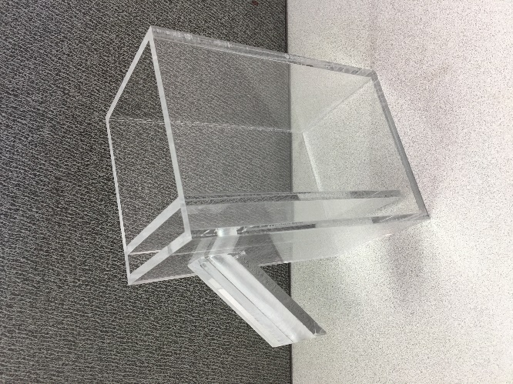
Figure 3-7(a). Example of a Displacement Vessel.

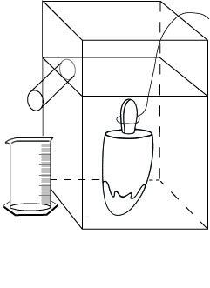

- Insulation shield
Styrofoam Board – minimum one-inch-thick
Styrofoam glue
Figure 3-7(b)(c)(d). Example of an Insulation Shield with Acrylic Displacement Vessel.
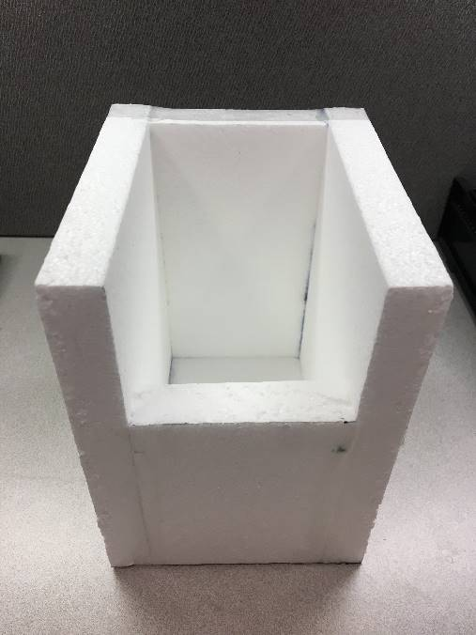  (b) | 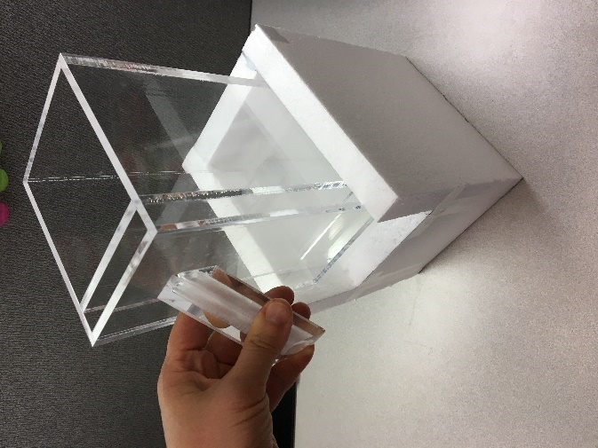  (c) | 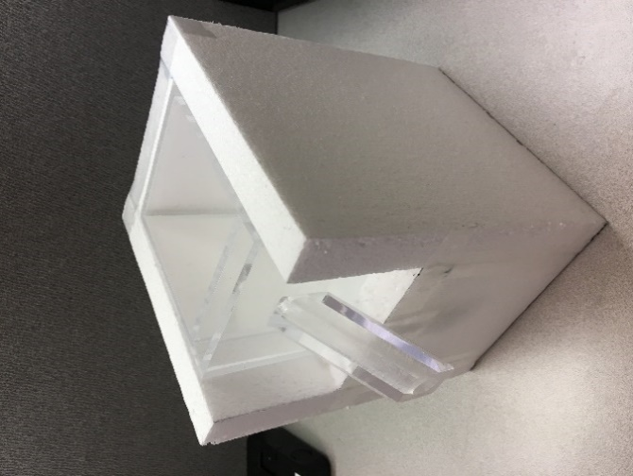 (d)
Figure 3-7(b)(c)(d). Example of an Insulation Shield with Acrylic Displacement Vessel,

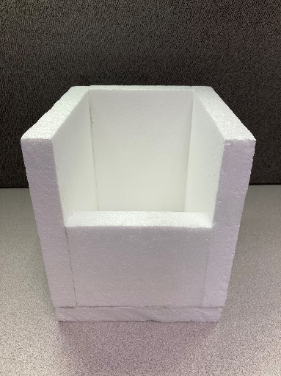  (e) | 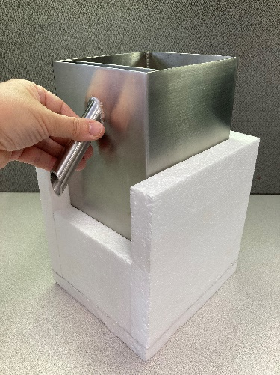  (f) | 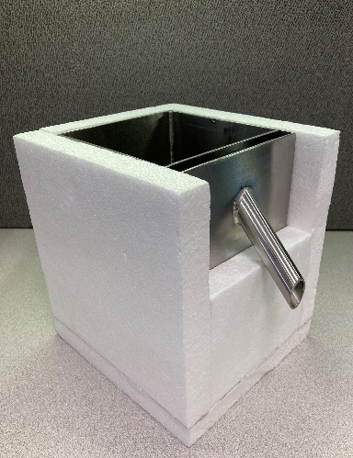  (g)
Figure 3-7(e)(f)(g). Example of an Insulation Shield with Metal Displacement Vessel
- Thin wire, clamp, or tongs

- Freezer or ice chest

- Single-edged razor or sharp knife (for sandwiches only)

- Prepared, chilled water /kerosene maintained at 1 °C (33 °F) or below
Ice Cubes and Dry Ice
(Safe Handling and Storage of Dry Ice | OSHA Safety Manuals Safe Handling and Storage of Dry Ice OSHA Safety Manual: https://www.safetymanualosha.com/safe-handling-and-storage-of-dry-ice/)
- Cryogenic gloves (for handling dry ice)

- Preparation container for prepared, chilled water with insulation (for protection from thermal transfer from ambient environment)

- Straining device to catch ice cubes and dry ice chunks from flowing into displacement vessel

- Indelible marker (for ice pops only)

- Level, at least 152 mm (6 in) in length

- Partial immersion thermometer or equivalent with 1 °C (2 °F) graduations and a − 35 °C to + 50 °C (− 30 °F to + 120 °F) accurate to ± 1 °C (± 2 °F)

- A tabletop, laboratory-type jack of sufficient size to hold the displacement vessel

- Stopwatch
3.11.2. Test Procedure
- Follow the procedures in Section 2.3.1. “Define the Inspection Lot.” Use a “Category A” sampling plan in the inspection; and select a random sample.

2. Place the assembled displacement vessel and insulation shield in a freezer or an ice chest filled with dry ice for at least 30 minutes prior to testing. It is advisable to pre-chill water for use as immersion fluid in a sufficient volume to fill the displacement vessel and to replenish as needed throughout the testing procedures by placing a container of water in a refrigerator or ice chest during the same period.

Note: The insulation shield should be assembled with dimensions that will cover as much surface area of the displacement vessel and minimal gaps between the seams (see Figure 3-7(b)(c)(d), “Example of an insulation shield with displacement vessel”). The purpose of the insulation shield is to reduce thermal transfer from the ambient environment to the displacement vessel to maintain the immersion fluid at 1 °C (33 °F) or below, as consistently as possible during testing.

Maintain the ice cream, ice pop or similar frozen novelty samples at the reference temperature for frozen products that is specified in Table 3-1. “Reference Temperatures for Liquids.” Place the samples in the freezer or ice chest until they are ready to be tested, and then remove packages from the freezer one at a time.

3. According to the type of novelty, prepare the sample products as follows:

- *Ice-pop. Mark on the stick(s) with the indelible marker the point to which the ice-pop will be submerged in the prepared, chilled water. (After the ice-pop contents have been submerged, remove the novelty to determine the volume of the stick.)

- *Cone. Make a small hole in the cone below the ice cream portion to allow air to escape.

- Sandwich. Determine whether the declared volume is (a) the total volume of the novelty (that is, including the cookie portion) or (b) the volume of the ice-cream-like portion only. If the declared volume is the volume of only the ice-cream-like portion, shave off the cookie with a razor or knife, leaving some remnants of cookie to ensure that no ice cream is accidentally shaved off. Work quickly and return the novelty to the freezer before the sandwich softens.

- Cup. Remove the cap from the cup.

- Prepare immersion fluid to a temperature of 1 °C (33 °F) or below by adding dry ice and ice cubes to water in a preparation container.
For best results, use an insulated preparation container to prevent thermal transfer from ambient air. Monitor the water temperature throughout this procedure by placing the thermometer in the center position of the pitcher.
Note: Be cautious while handling dry ice due to its very low temperature (-109 ˚F); handle it with cryogenic gloves to prevent frostbite or freezer burns to skin.
Note: Dry ice (-109 ˚F) is the key ingredient for the chilled water immersion fluid preparation because of its very low temperature. However, while the dry ice lowers the water mixture temperature, the water surface that is in contact with the ambient air in the testing environment is also constantly gaining heat due to heat transfer. To resolve this problem, add ice cubes to the water; the ice cubes will float and form an insulation barrier, thereby, allowing water temperature to be maintained at the required temperature. The approximate ratio to make the prepared, chilled water (can reach as low as 31.6 °F) are as follows:
Water : Dry ice : Ice cubes = 6 parts : 1 part : 2 parts
Note: Monitoring of the temperature of the chilled water immersion fluid should be conducted throughout the testing. At any time that the chilled water temperature exceeds 1 °C (33 °F), a new batch of chilled water at the required temperature will need to be prepared to validate the testing procedure.
- When the displacement vessel and the insulation shield are both chilled and ready to be used, remove from freezer and set up on testing surface.
6. 4. Fill the displacement vessel with ice prepared, chilled water until it overflows the spout. Use a strainer to prevent ice cubes or dry ice chunks from flowing into the displacement vessel. Allow it to sit until dripping stops. Raise the displacement vessel with a tabletop laboratory-type jack as necessary and place the graduate of appropriate capacity beneath the spout.

7.5. Remove a package from the freezer, determine its gross weight, and record it.

8.6. Submerge the novelty as suggested until it is below the surface level of the water.
  - Ice-pop. Use a clamp, tongs, or your fingers to hold the stick(s) and submerge the ice-pop to the level marked in Step 3 of the Test Procedure.
  - Cone. Shape the wire into a loop, and use it to push the cone, headfirst (ice cream portion first) into the prepared, chilled water. Do not completely submerge the cone immediately: let water fill the cone through the hole made in Step 3 of the Test Procedure before completely submerging the novelty.
  - Sandwich or cup. Skewer the novelty with the thin wire or form a loop on the end of the wire to push the sandwich or ice cream portion or cup completely below the liquid level.

9.7. Record the total water volume in the graduate.
- For a cone or sandwich, record the water volume as the net volume and go to Step 9.
- For ice-pops or cups, record the water volume in the graduate as the gross volume and go to Step 8.
10.8. Refill the displacement vessel with prepared, chilled water to overflowing and reposition the empty graduate under the spout. After the cup and novelty contents have been submerged, remove the novelty from the cup to determine the volume of the cup.

- Ice-pop. Melt the ice-pop off the stick or sticks. Submerge the stick or sticks to the line marked in Step 3. Record the volume of tare material (i.e., stick) by measuring the water displaced into the graduate. The net volume for the ice-pop is the gross volume recorded in Step 7 minus the volume of the tare materials in this step. Record this volume as the “volume of novelty.” To determine the error in the package, subtract the labeled quantity from the volume of novelty.

- Cup. Remove the novelty from the cup. Rinse the cup, and then submerge it in the displacement vessel. Small pinholes in the base of the cup can be made to make submersion easier. Record the volume of water displaced into the graduate by the cup as the volume of tare material. The net volume for the novelty is the gross volume determined in Step 7 minus the volume of the tare materials determined in this step. Record this as the net volume of the novelty. To determine the error in the package, subtract the labeled quantity from the volume of novelty.

11.9. Clean and air-dry the tare materials (sticks, wrappers, cup, lid, etc.). Weigh and record the weight of these materials for the package.

12.10. Subtract the tare weight from the gross weight to obtain the net weight and record this value.

13.11. Compute the weight of the labeled volume for the package using the following formula and then record the weight:
Product Density = (product net weight in Step 10) ÷ (the total water volume in Step 7 – volume of tare material in Step 8)
Weight of labeled volume = (labeled volume) × (Product Density)
14.12. Repeat Steps 3 through 11 for a second package.
Note: Monitoring of the temperature of the prepared, chilled water should be conducted throughout the testing. At any time that the chilled water temperature exceeds 1 °C (33 °F), a new batch of chilled water at the required temperature will need to be prepared to validate the testing procedure.

Repeat prepared, chilled water preparation and freezing of insulation shield and displacement vessel as needed throughout the inspection time period.
15.13. If the weight of the labeled volumes in Step 11 for the two packages differs from each other by more than one division on the scale, the gravimetric test procedure cannot be used to test the sample for compliance. If this is the case, use Steps 3 through 8 for each of the remaining packages in the sample to determine their net volumes and package errors. Then go to evaluation of results. If the weights of the labeled volumes agree within one division, continue to Step 14 to test the rest of the sample using the gravimetric test procedure.*
16.14. Use Section 2.3.5.1. “Determination of Tare Sample and Average Tare Weight” to determine the Average Used Dry tare Weight of the sample.

17.15. Find the Average Product Density by adding the densities of the product from the two packages and dividing the sum by two.

18.16. Using the weight of labeled volume determined in Step 11, calculate the Average Product Weight by multiplying the weight of the labeled volume by the average product density.
*Average Product Weight = Labeled Volume × Average Product Density
19.17. Calculate the “nominal gross weight” using the formula:
Nominal Gross Weight = Average Product Weight + Average Used Dry Tare Weight
20.18. Weigh the remaining packages in the sample.

21.19. Subtract the nominal gross weight from the gross weight of each package to obtain package errors in terms of weight.

Note: Compare the sample packages to the nominal gross weight.
22.20. Determine the average package error by totaling all package errors and dividing by the number of packages in the sample.

To convert the average error or package error from weight to volume, use the following formula:
Package Error in Volume = (Package Error in Weight) ÷ (Average Product Density)

Evaluation of Results
Follow the procedures in Section 2.3.7. “Evaluate for Compliance” to determine lot conformance.
Testing Data
Data Analysis and Summary Justification
The following data summarizes the test of various materials for displacement vessels for this procedure. Materials considered were acrylic and metal in a variety of settings (ambient, with insulation, with insulation and prior chilling in freezer). These materials were chosen to reflect the variety used in typical, current displacement vessel fabrication.
The acrylic displacement vessel, combined with the insulation shield (with prior chilling), had the most favorable and reliable results for temperature stability. With the insulation and prior chilling, temperature stability in the acrylic displacement vessel significantly increased from 53 seconds of maintaining the temperature below 33.1 ˚F to 93 minutes and 53 seconds.
- Displacement Vessel at Room Temperature (Without Insulation Shield)

Data below recorded length of time that water temperature stayed below 33.1˚F.
Tester Material | Time (min: sec)
Metal | 00:00
Acrylic | 00:53

- Displacement Vessel at Room Temperature (With Insulation Shield)

Data below recorded length of time that the water temperature stayed below 33.1˚F.
Tester Material | Time (min: sec)
Metal | 00:00
Acrylic | 00:52

- Displacement Vessel Chilled in Freezer for 30 minutes Prior to Test (Without Insulation Shield)
Prior to the testing, the displacement vessel was chilled in freezer prior to test for half an hour (30 mins).
Data below recorded length of time that the water temperature stayed below 33.1˚F.
Tester Material | Time (min: sec)
Metal | 06:30
Acrylic | 13:22

- Displacement Vessel and Insulation Shield Chilled in Freezer for 30 minutes Prior to Test
Prior to the testing, displacement vessel and insulation shield chilled in freezer for half an hour (30 mins).
Data below recorded length of time that the water temperature stayed below 33.1˚F.
Tester Material | Time (min: sec)
Metal | 36:16
Acrylic | 93:50

Previous Action:
2024: New Proposal
Original Justification:
The existing Handbook 133 procedure does not include guidance on the preparation of chilled water as an immersion fluid at the required temperature [1 °C (33 °F) or below]. As such, it can be difficult to maintain the immersion fluid for a reliable duration at the required temperature [1 °C (33 °F) or below] after the chilled water is poured into the displacement vessel. Water temperature exceeding 1 °C (33 °F) will result in the potential melting or softening of the ice cream or frozen novelty, thus resulting in inaccurate testing data and consequently invalidate or invite challenges to the inspection findings.
The submitter asked that this be an Informational Item in 2024
Comments in Favor:

Regulatory:
- 2024 Interim: Mr. Matthew Douglas, CA- believes the item is complete and supports Voting Status. Regarding previous negative comments about the cost of the apparatus, he stated its cost is comparable to others. He also posed the question What happens if the ice cream melts?

- 2024 Interim: Mr. Jim Willis, NY- also expressed his support of this item and added this is a laboratory procedure not a field procedure.

- 2024 Interim: Mr. Austin Shepard, San Diego County- explained when the ice cream melts, its volume changes. He explained this proposal only adds Styrofoam (insulation), dry ice (temperature control) and updates the methods for their use, increasing control of water temperature for an extended period in which to perform the tests, up to a half an hour. He supports the voting status of the item with the changes offered by the submitter.

- 2024 Interim: Mr. Kurt Floren, County of Los Angeles, expressed the importance of and the need for more package inspections. He said the costs may be a high investment for those that don’t do a lot of inspections and explained the procedure has been in place for at least 30 years. This is just un update including insulation and chilling procedure. Water must be maintained at no more than 33 degrees (just above freezing). Regarding the term “Parts” he stated in that context it is by all known as equivalent volume. He suggested a title clean up by the committee to include popsicles and other frozen novelties and supported the item moving forward with voting status.

- 2924 Interim: Mr. Jose Arriaga, Orange County California supported the item.
Industry:
- None
Advisory:
- None
Comments Against:
Regulatory:
- None
Industry:
- None
Advisory:
- None
Neutral Comments:
Regulatory:
- None
Industry:
- None
Advisory:
- 2024 Interim: Mr. John McGuire, NIST OWN, recommended developing status. He shared concerns with the submitter and said he may have more after hearings and review of suggested editorial changes by the submitter.

- 2024 Interim: Mr. David Sefcik, NIST OWM, suggested clarification on making the chilled water, 1 to 6; what is a “part”, as in, how much is a part.
Item Development:
NCWM 2024 Interim: The Submitter gave a presentation and provided the Committee with some suggested edits. During the Open Hearing the Committee heard comments from several regulators in support of this item moving forward with a Voting status. At the Interim, the Committee assigned Voting status to the item including all suggested language changes provided by the submitter.
After the Interim meeting, the Committee received additional information and edits from NIST OWM regarding the item. The concern raised was that the language provided by the submitter was limiting regarding products to be tested with this test method. Mr. John McGuire, NIST OWM, worked with the submitter on developing edits to address the concern and provided the Committee with them.
One of the edits was to the title of the section. This change prompted the need to align its title with the title in the Method of Sale of these commodities. In response, the committee created item MOS 24.5 to align the title of both sections and blocked it with NET 24.1. in Item Block 3 (B3). The status assigned to these items are Voting for NET 24.1 and Informational for MOS 24.5
Regional Associations’ Comments:
New Proposal
CWMA 2023 Interim: No comments were heard.

The committee recommends this item be informational for more comments to come in.
WWMA 2023 Annual: A presentation was given by the submitter of this item during open hearings and is available on the WWMA website. The submitter recognized editorial changes submitted by Matt Douglas, CDFA-DMS. The submitter stated that this item is fully developed and would like a Voting status.
Austin Shepherd, County of San Diego, California voiced his support for the proposal as voting.
Matt Douglas, California Department of Food and Agriculture, Division of Measurement Standards echoed the comments of Mr. Shepherd, voicing support for the item with the adoption of his editorial changes.
Kurt Floren, County of Los Angeles, California stood to thank Annie Tsou and Lina Ng of LA County for their hard work on this submission. Mr. Floren stated that it is absolutely critical to maintain the temperature of the water during this test procedure. Mr. Floren also stated that this item also cleans up code, and fully supports this as a voting item.
Jose Arriaga, County of Orange, California also voiced support for this item with the editorial changes.
The WWMA L&R Committee recommends this item as a Voting item.

B3: MOS-24.5 I Section 1.7.1. Factory Packaged Ice Cream and Similar Frozen Products
Source:
Laws and Regulations Committee
Purpose:
To amend the language in NIST Handbook 130, section 1.7.1. to align with Section 3.11 Ice Cream Novelties.

Item Under Consideration:
Amend the language in NIST Handbook 130, section 1.7.1. as follows:
1.7.1 Factory Packaged Ice Cream, Ice Pops, and Similar Frozen Products. Novelties – Ice cream, ice milk, frozen yogurt and similar products shall be kept, offered, or exposed for sale in terms of fluid volume.
Previous Action:
2024: New Proposal
Original Justification:
The existing Handbook 130 Section 1.7.1 title does not align with the test methods in Item 24.1 This item aligns the two sections.
Comments: The Committee developed and included this item after the 2024 Interim meeting; thus, no comments were heard on it during the Interim meeting.
Item Development:
NCWM 2024 Interim: After the Interim meeting, the Committee received additional information regarding NET 24.1 that it conflicted with NIST Handbook 130 Section 1.7.1 Factory Packaged Ice Cream, and Similar Frozen Products. The Committee added MOS 24.5 to amend the title of NIST Handbook 130 section 1.7.1. to resolve the conflict.
The Committee has worked with the submitter to resolve the issue, and both agree with the proposed item as it appears here.
The Committee blocked this item with NET 24.1 and assigned Informational status to it. NET 24.1 was assigned Voting status.

Mrs. Sandy Wyss, Missouri | Committee Chair
Mr. Wyatt Spieker, Iowa | Member
Mr. Tim White, Michigan | Member
Mrs. Brenda Geist, Kansas | Member
Scott Fenwick, Clean Fuels Alliance America | Associate Member
Mike Harrington, Iowa | NCWM Representative
CWMA Laws and Regulations Committee

